**Engineering 498: Team 16051**

**Active Elbow Orthosis**

Final Report





**Table of Contents**

1.0 S**cope**

*1.1 Background / History*

*1.2 Need Statement*

*1.3 Concept of Operations*

*1.4 Stakeholders*

*1.5 System Functional Requirements*

*1.6 Changes since CDR*

2.0 System Block Diagram

3.0 Drawings

4.0 Software Design Documents

5.0 Acceptance Test Procedure

*5.1 Test Procedure Verification and Data Sheet: AEO Lock (1.0)*

*5.2 Test Procedure Verification and Data Sheet: Motor Torque (2.0)*

*5.3 Test Procedure Verification and Data Sheet: Position Tolerance (3.0)*

*5.4 Test Procedure Verification and Data Sheet: AEO Sensor (4.0)*

*5.5 Test Procedure Verification and Data Sheet: Angular Speed (5.0)*

*5.6 Test Procedure Verification and Data Sheet: Sensor App Accuracy (6.0)*

*5.7 Test Procedure Verification and Data Sheet: Temperature Range (7.0)*

*5.8 Test Procedure Verification and Data Sheet: Weather (8.0)*

*5.9 Test Procedure Verification and Data Sheet: Battery Life (9.0)*

*5.10 Test Procedure Verification and Data Sheet: Battery Recharge (10.0)*

6.0 Models and Analyses

*6.1 Torque Model*

*6.2 Motor Power Model*

*6.3 Sensor Model*

*6.4 Weight Analysis*

*6.5 Temperature Analysis*

*6.6 Sensor Analysis*

*6.7 Step Angle Analysis*

*6.8 Sampling Analysis*

7.0 Acceptance Test Results

*7.1 Test Results: AEO Lock (1.0)*

*7.2 Test Results: Motor Torque (2.0)*

*7.3 Test Results: Position Tolerance (3.0)*

*7.4 Test Results: AEO Sensor (4.0)*

*7.5 Test Results: Angular Speed (5.0)*

*7.6 Test Results: Sensor App Accuracy (6.0)*

*7.7 Test Results: Temperature Range (7.0)*

*7.8 Test Results: Weather (8.0)*

*7.9 Test Results: Battery Life (9.0)*

*7.10 Test Results: Battery Recharge (10.0)*

8.0 Final Budget

9.0 Lessons Learned

10.0 Appendices

*10.1 Drawings PDFs*

*10.2 Solidworks PDFs*

*10.3 Models and Analyses Documents*

*10.4 Wireless Application Instruction Document*

**1.0 Scope**

### **1.1 Background / History**

Orthotic devices have been essential in correcting deformities and stabilizing post-operative limbs and joints for many years. For postoperative orthoses, the exact method of rehabilitation has been the doctor’s conclusion. Lower limb orthoses have been widely more popular than upper limb orthoses, and the method for rehabilitating both are quite different. While the existing products on the market for an upper limb orthotic brace consists of rigid, locked device, there are other recent tools used to passively move the elbow joint.

The device on the market for elbow rehabilitation is called a CPM, also known as a continuous passive movement device. The idea is that the device will passively flex and extend the arm without the patient using their muscles to create this movement. The goal of the CPM is to move the synovial fluid, and avoid both scar tissue and cartilage buildup. The most necessary component of the CPM that will be integrated with the Active Elbow Orthosis is the controlled range of motion parameter. The doctor programs the device to move the joint within a range of angles, and slowly increases this range throughout the healing process. This concept will be integrated with the elbow brace to allow the patient to move their joint a certain amount while wearing the device. The downside to the CPM is the fact that the patient is not actively moving their limb – the device performs this movement passively. To improve this device for the elbow joint, the option to move the elbow actively would greatly facilitate the healing process by virtue of stimulating the muscles to move. The new system for the elbow will carry out the motor traits that the CPM contains, only the motor will not be able to entirely move the limb alone; the brace requires movement from the patient.

Another device on the market that is currently being implemented by many orthopedic surgeons after surgery is called the Dynasplint. While this device is offered as a lower limb orthosis and an upper limb orthosis, the elbow flexion device is most similar to the improved Active Elbow Orthosis. The Dynasplint is responsible for restoring the patient’s range of motion in their arm by immobilizing it for the duration of the wear in order to reduce inflammation. The idea of the splint is to provide a low-load extended stretch while it is fastened to the arm. The benefit of the Dynasplint is that is allows the stiff joint to be engaged in a deep stretch while the patient is inactive. Similarly to the CPM, the patient is not required to assist in the healing of the joint until he/she begins physical therapy. The only drawback to this form of healing is the fact that the patient is not actively moving the joint while it is being stretched. This will not achieve the desired scar tissue breakdown like the Active Elbow Orthosis. The new system would be an improvement from the Dynasplint because it would allow the doctor to program how long the patient will be stretching the joint, as well as the parameters the patient should be moving the elbow after it has been stretched. The new device will also assist the patient in these movements by guiding the joint using a motor, but it will still require the patient to put in at least half the effort to achieve the movement.

While there is an endless list of postoperative elbow orthoses, the last product similar to the Active Elbow Orthosis is called the UltraFlex Custom for Bi-Directional EO. This device is specifically designed to treat a triceps or a biceps rupture, but the goal is to hinder the movement of the arm by implementing a variety of locking devices. The doctor is able to control the angle at which the brace can lock, providing the patient with the ability to move his/her arm, but only to a specific angle before the lock becomes effective. The benefits of this device include the fact that there are two hinges on either side of the elbow, which assist in the movement of the joint; however, the joint is still being controlled because of the locking system. The doctors or physicians are responsible for changing the different locks on the device that correspond with the patient’s healing process. Unfortunately, this brace is designed to improve the muscles after surgery or trauma instead of the elbow joint. Focusing on the elbow joint will be the first improvement made on the UltraFlex elbow orthosis. The next improvement that will be made to this device is the addition of the Wireless/iOS interface. This will allow the doctor or physician to alter the range of motion that the patient should be achieving through the app on the computer or phone. Rather than changing the locking system every 10-20 days until the full range of motion is achieved, the iOS interface will allow continuous communication between the doctor and the patient on the rehabilitation process.

With the Active Elbow Orthosis, the many benefits that are offered through the three devices stated above will be harmonized together. While minimizing the doctor/patient visits, this brace will maximize the possible rehabilitation necessary to achieve the full range of motion that is desired.

### **1.2 Need Statement**

Elbow stiffness after surgery is a common and debilitating problem. It is caused by the accumulation of fibrous tissue in the joint and surrounding structures during the healing process and can occur after many types of elbow surgery. It is made worse by the rigid postoperative bracing that is used to stabilize the elbow after surgery. It is commonly treated with range of motion exercises performed daily, but the exercises can be painful and are often ineffective. Thus, there exists an unmet need for a brace that simultaneously stabilizes the elbow after surgery and provides frequent motion to prevent the buildup of scar tissue and maintain the range of motion of the elbow joint.

The goal of this project is to design and create a motor-hinged elbow orthosis that will maintain as much range of motion in the joint throughout the six-month healing process while also breaking down the scar tissue in the joint. This device should aid recovery after surgery, having the advantage over physical therapy of being wearable and user controllable. While performing the flexion/extension movement in the arm, the orthotic will actively assist the patient into moving the arm to a predetermined angle per doctor’s orders. This elbow orthosis will be a staple in the orthopedic surgical department.

### **1.3 Concept of Operations**

**System Boundaries**

There are a number of different interfaces that need to be accounted for in the final product. The frame of the elbow brace will interface with the sensor, such as an IP Motion Sensor, to detect the angle of the arm. This interface is critical as proper detection of the arm angle determines the effectiveness of the device. To be effective, the angle measurement must be within 2.5o either way of the actual angle of the arm. The sensor interfaces with the iOS application via a wireless connection. The iOS application then relays the measurements and determines whether the brace should continue its movement of reverse its motion.

To continue the motion of the brace or reverse its motion, the iOS application interfaces with the motor. If the maximum arm angle is reached, which is determined by the range of motion parameters, the iOS application signals to the motor to stop and reverse its motion guiding the arm to stop extending and begin flexing. The motor then interfaces with the actual brace as it controls the action of the device. The motor delivers the torque necessary to extend the brace and fold it.

**System Environment**

While the Active Elbow Orthosis is a wearable and user controllable device, there are still limits on the exact environment where maximum performance is attained. First of all, the brace is designed using a motor to assist the movement of the elbow, so any extreme hot or cold conditions would decrease the performance of the motor and the sensors that are integrated into the system. Ideally, the patient should be using the brace indoors while in an area free of recreation to prevent the brace from performing incorrectly or breaking. But realistically the brace can be worn indoors and outdoors in an environment free of water. The brace is designed for the patient to use for a few hours a day to prevent the power in the motor from depleting. The device should be operated in an environment where the smartphone is nearby to access the app that controls the brace. The brace should not be operated in a densely populated area, or an area where the brace could potentially break. The brace should not be near water or exposed to water which could cause damage to the motor and the batteries that operate it. This device should also be removed while the patient sleeps.

**System Constraints**

Based on the market research and previous devices, the manufacturing costs of this device should be approximately $500. Current elbow brace devices in the market without any motorized activity run approximately $100-$300. The total cost for the production of the AEO was approximately $800 without accounting for the consultant and machine shop work. With items and resources bought in bulk, this cost would be less in the manufacturing line; approximately 20% less, totaling to approximately $600. Thus, to be competitive on the market and generate a profit, the device must be able to be manufactured for under $600, so it can be sold for a similar price or less.

The iOS application will be written in Xcode using the programming language Swift. Using Xcode will be the easiest and most efficient way to create the application, despite other potential methods of creating it.

The life expectancy of the device is a full day. A full day of use allows the consumer to recharge it while he or she is not using it at night; and if it is only used for a brief time during the day, then the battery may last for several days. The battery has a way to be recharged and not need to be replaced every time it dies. The device attaches to the mounting on the brace, which makes it adjustable in length and the cuff size around the arm can change as well. The device does not weigh more than 5 pounds. The consumer will be placing this device on his or her arm as part of a therapeutic recovery process, thus, it is lightweight and not very strenuous on the arm. The device does not deliver more than 30 Newton-centimeters of torque. The device is intended to be an active assist device, which means the force of the device should not be able to move the arm against a resistance. Rather the device should simply assist the motion of the arm.

**System Use**

The Active Elbow Orthosis will be ultimately designed for both adults and children, however the initial design will be for adult users. The most ideal scenario for the brace to be used is as follows:

Immediately post operation, the Active Elbow Orthosis is placed on the patient.

The patient will be given a 10-day healing process where he/she will immobilize the elbow to prevent the stitches and staples from tearing. Once the 10-day healing process is complete, the doctor will program the device with the corresponding app, and enter in the rehabilitation process he/she sees fit for the next three-six months. The app will be communicating to the motor and the sensors inside the brace via Wifi, and the doctor’s exercises will be viewable to the patient on their app on their smartphone. The user will turn the motor on through the app, and the Wifi will connect to the app on the interface. The doctor will have inputted the range of angles he/she feels the elbow should be exercised, and how many repetitions will be necessary. The patient will begin his/her exercising by slowly extending the elbow with assistance from the motor until the desired angle is reached. Once the desired angle is reached, the device will communicate that information to the app, the motor will stop, and the system will stop. The motor will reverse allowing the elbow to flex and move back to the starting angle. Flexing and extending the arm will continue until the number of reps the doctor orders has been achieved. The patient will then lock the device in the proper immobile position to encourage the prolonged stretch, and then he/she will power down the system. If the patient feels that the exercise was simply unbearable, he/she will input that into the app which will alert the doctor of the circumstances. The doctor will then be able to write a new rehab schedule with a smaller range of motion acquired on the app which will be immediately viewable to the patient.

In the event that the user attempts to move the brace past the programmed angle, the device will provide feedback to via the iOS application alerting the user the desired angle has been reached, or the mechanical lock will prevent further motion. By using this locking system, the user will not be able to put an extensive amount of force on the brace that would inevitably break the motor.

A slip clutch will be able to solve the motion problem for most medical equipment. This method is at a lower cost and lasts longer than alternative methods. Slip-clutch capacity is dependent on torque, rpm, and duty cycle. For overload protection, a slip clutch can be anything from a simple shear pin, to a ball detent, to a more complex device with friction pads.

In case that the motor stops working unexpectedly, or the app stops communicating with the device, the user will be instructed to power down the device through the app and restart it. This will prevent the possibility of the motor overheating. The app will also let the user know when the battery on the device is running low, and it will immediately shut the device off when the battery dies.

### **1.4 Stakeholders**

In the design and production of a new device, it is important to keep in mind all those who have a vested interest in the success of the product. To get the project started, there must be organization, a clear process, and an achievable goal. These are put into place by a sponsor. For this project, Dr. Daniel Latt invests his time and oversees all operations. Dr. Latt is one of the main stakeholders on this project due to his invested time and resources, and he would like to see measurable results. In terms of those working on the project, all team members would be stakeholders in the device as their name would potentially be listed on any patent that would come as a result of the work on the project.

Other stakeholders in the project would be patients suffering from a stiff elbow joint and scar tissue buildup after elbow surgery. This device has the potential to help a patient regain normal function and mobility in the elbow during their recovery from an elbow injury. Any patient seeking the best possible treatment during their recovery would be a stakeholder in this device. Along those similar lines, physical therapy companies are always looking for the most effective means of treatment to help current patients and attract new ones. These companies would certainly be stakeholders in a device that could potentially benefit their business.

**1.5 System Functional Requirements**

|  |  |  |  |  |  |  |  |  |
| --- | --- | --- | --- | --- | --- | --- | --- | --- |
| ID | System Requirement  Level 1 | Subsystem Requirement  Level 2 | Specification | Status | Test | Analysis | Inspection | Demonstration |
| 3.1 | Required System States and/or Modes |  |  |  | - | - | - | - |
| 3.1.1 | AEO Lock |  | < 30-50 lbs | Done | x |  |  |  |
| 3.1.2 | Release Mechanism |  |  | Done |  |  |  | x |
| 3.1.3 | Range |  |  | Done |  |  |  | x |
| 3.2 | System Capability Requirements |  |  |  | - | - | - | - |
| 3.2.1 | AEO Activation |  |  | Done |  |  |  | x |
| 3.2.2 | AEO Measurement |  |  | Done |  |  |  | x |
| 3.2.3 | Motor Torque |  | <35 N cm | Done | x |  |  |  |
| 3.2.4 | Position Tolerance |  | <2.5˚ | Done | x |  |  |  |
| 3.2.5 | Motor Response |  |  | Done |  |  |  | x |
| 3.2.6 | Removal of Motor |  |  | Changed | x |  |  |  |
| 3.2.7 | AEO Sensor |  |  | Done | x |  |  |  |
| 3.3 | System External Interface Requirements |  |  |  | - | - | - | - |
| 3.3.1 | Battery Life |  | 5-10 min | Done | x |  |  |  |
| 3.3.2 | Battery Recharge |  | < 12 hours | Done | x |  |  |  |
| 3.3.3 | Battery Communication |  |  | Done | x |  |  |  |
| 3.3.4 | Angular Velocity Feedback |  | <10˚ / sec | Done |  |  |  |  |
| 3.3.5 | Feedback |  |  | Done |  |  |  | x |
| 3.4 | System Internal Interface Requirements |  |  |  | - | - | - | - |
| 3.4.1 | Angular Speed |  | <10˚ / sec | Done | x |  |  |  |
| 3.4.2 | Communication Distance |  | <5 ft | Done |  |  |  | x |
| 3.5 | System Internal Data Requirements |  |  |  | - | - | - | - |
| 3.5.1 | Sample Rate |  |  | Done |  |  |  | x |
| 3.5.2 | Sensor Accuracy |  | <2.5˚ | Done | x |  |  |  |
| 3.6 | Safety Requirements |  |  | Done | - | - | - | - |
| 3.6.1 | Emergency Shut Down |  |  | Done | x |  |  |  |
| 3.6.2 | Water Safety |  |  | Done | x |  | x |  |
| 3.6.3 | Communication Error |  |  | Done |  |  |  | x |
| 3.7 | Security and Privacy Requirements |  |  |  | - | - | - | - |
| 3.7.1 | User Input |  |  | Done |  |  |  | x |
| 3.8 | System Environment Requirements |  |  |  | - | - | - | - |
| 3.8.1 | Temperature Range |  | 32˚-104˚ | Done |  |  |  |  |
| 3.8.2 | Weather |  | rain | Done |  |  |  |  |
| 3.9 | Computer Resource Requirements |  |  |  | - | - | - | - |
| 3.9.1.1 | Device and App Communication | Computer Hardware Requirements |  | Done |  |  | x |  |
| 3.9.1.2 | Motor Communication | Computer Hardware Requirements |  | Done |  |  | x |  |
| 3.9.2.1 | iOS Compatibility | Computer Software Requirements |  | Done |  |  | x |  |
| 3.9.3.1 | Data Transfer | Computer Communications Requirements |  | Done |  |  |  | x |
| 3.10 | System Quality Factors |  |  |  | - | - | - | - |
| 3.10.1 | Functioning |  |  | Done |  |  |  | x |
| 3.10.2 | Battery Life |  |  | Done |  |  |  | x |
| 3.10.3 | Durability |  |  | Done |  |  | x | x |
| 3.10.4 | Removable Parts |  |  | Done |  |  |  | x |
| 3.10.5 | Accessibility |  |  | Done |  |  |  | x |
| 3.10.6 | Reusability |  |  | Done |  |  |  | x |
| 3.10.7 | Usability |  |  | Done |  |  |  | x |
| 3.11 | Design and Construction Constraints |  |  |  | - | - | - | - |
| 3.11.1 | Weight |  | <10 lbs | Done |  |  | x |  |
| 3.11.2 | Fastening Mechanism |  |  | Done |  |  |  | x |
| 3 11.3 | Comfortability |  |  | Done |  |  | x |  |
| 3.11.4 | Size Adjustment |  |  | Changed |  |  |  | x |
| 3.11.5 | Motor/Battery Detachment |  |  | Changed |  |  |  | x |
| 3.11.6 | Pronation/Supination |  |  | Done | x |  |  |  |
| 3.11.7 | Battery Placement |  |  | Done |  |  |  | x |
| 3.11.8 | Motor Placement |  | < 4 cm | Done |  |  | x |  |
| 3.12 | Personnel Related Requirements |  |  |  | - | - | - | - |
| 3.12.1 | Usage Time |  | 24 hours / day | Done |  |  |  | x |
| 3.12.2 | Device Instructions |  |  | Done |  |  | x |  |
| 3.12.3 | Instructions Language |  |  | Done |  |  |  | x |
| 3.13 | Logistics Related Requirements |  |  |  | - | - | - | - |
| 3.13.1 | Battery and Motor Maintenance |  |  | Done |  |  |  | x |

### **1.6 Changes Since CDR**

Through the process of building and testing of the device, there were some features that required a change in order to proceed and meet all the functional requirements for the AEO. There were five Engineering Changes Request forms done, all which were accepted by the sponsor, and executed on the new device. From the changes requested include, addition of plates to the arm brace, wifi connectivity, case constructed with PETg material, gearbox implementation, and notch implementation. The Engineering Changes Request Forms are found at the end of this section.

An additional change needed to be implemented due to a request of our sponsor, was the creation of a new hinge brace. In the previous model a sponsored brace was used and implemented to the AEO design. However, an alternative hinge model was created, where this new hinge brace eliminates the need of aluminum plates attached on the surface. The function of the plates to interact with the keyed shaft from the housing has been implemented on the new hinge brace, as well as the alignment notch. With the use of this new hinge brace there is a decrease in weight and volume. Images of this new hinge can be found in the Appendix.

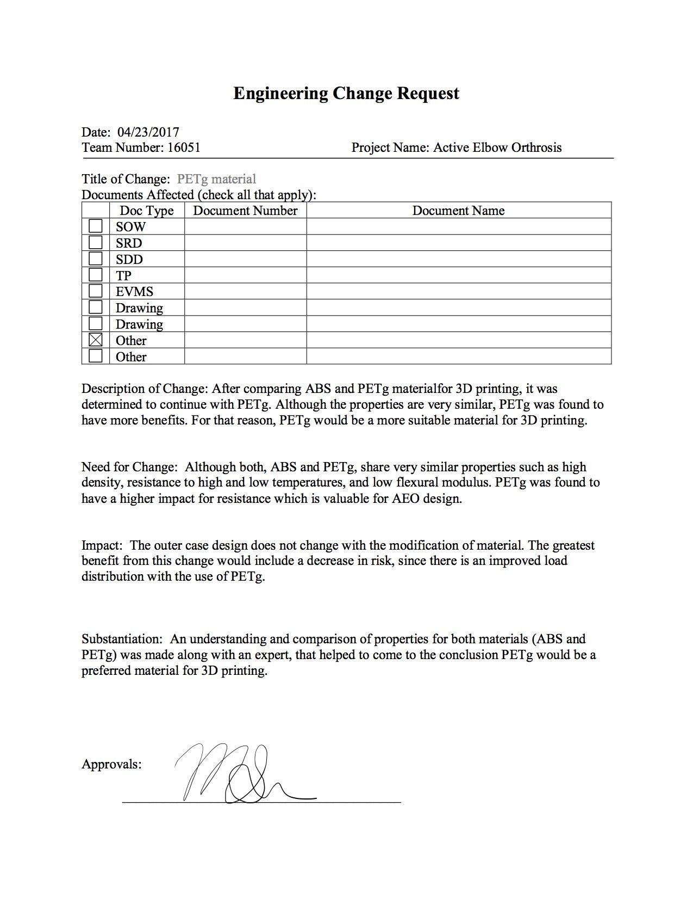

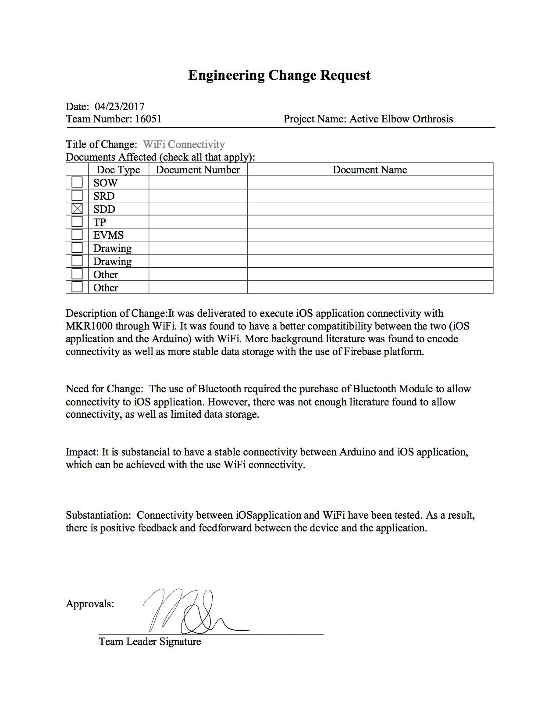



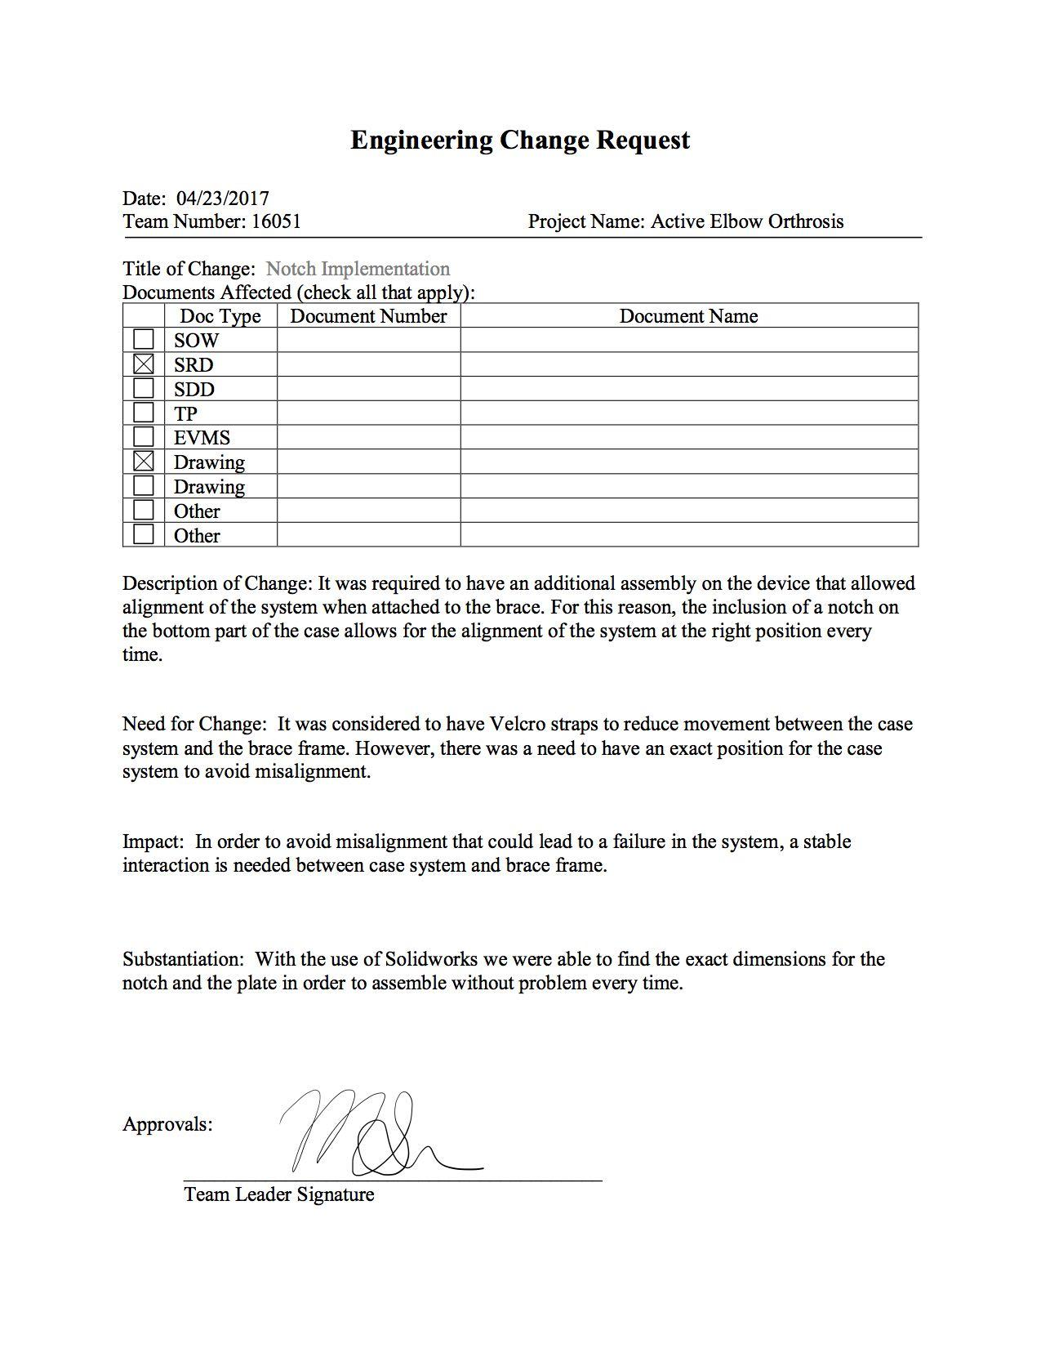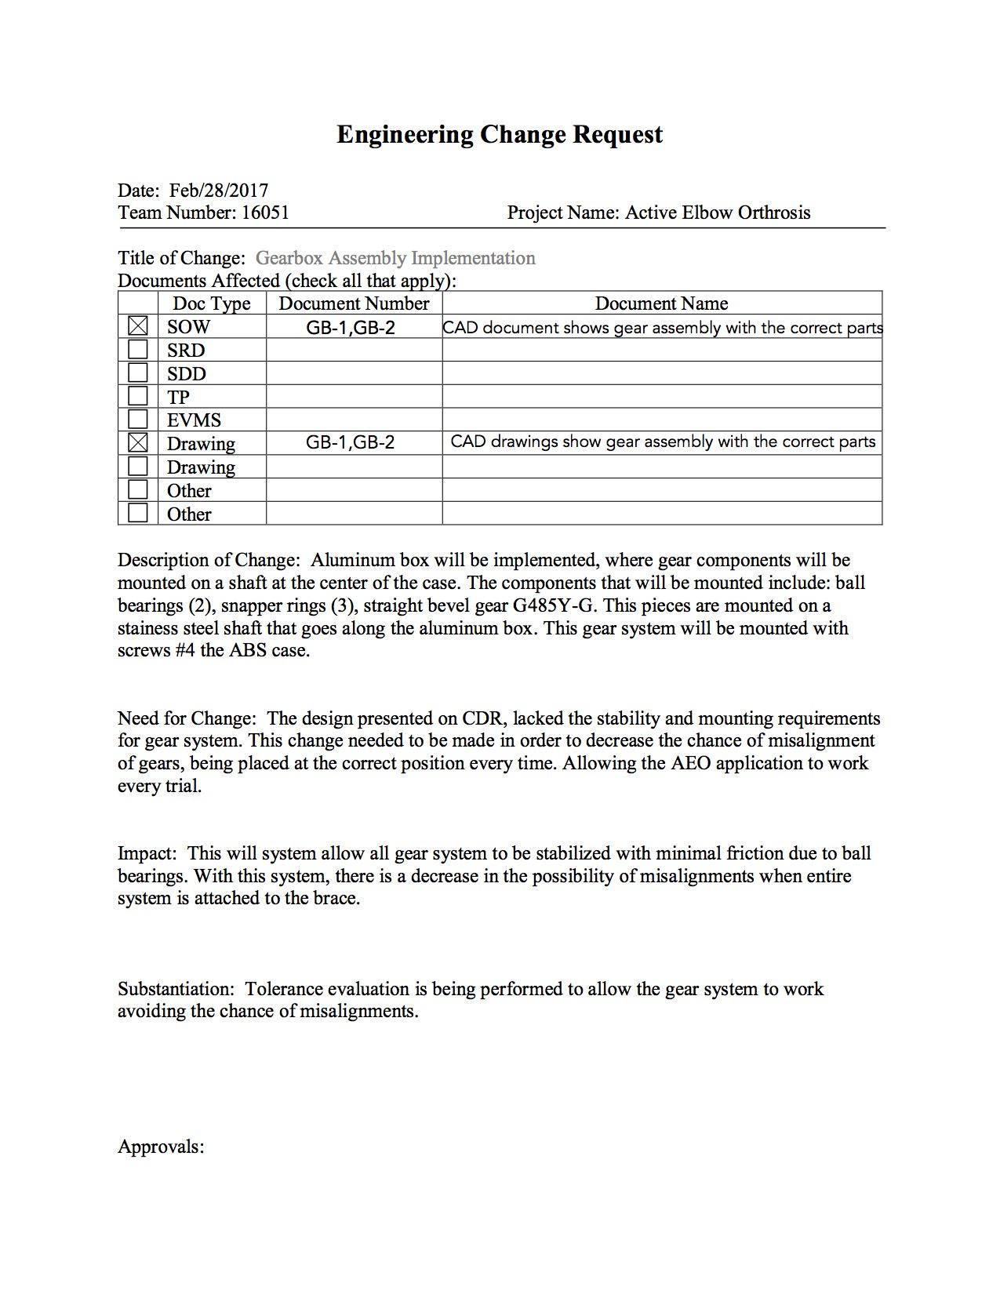



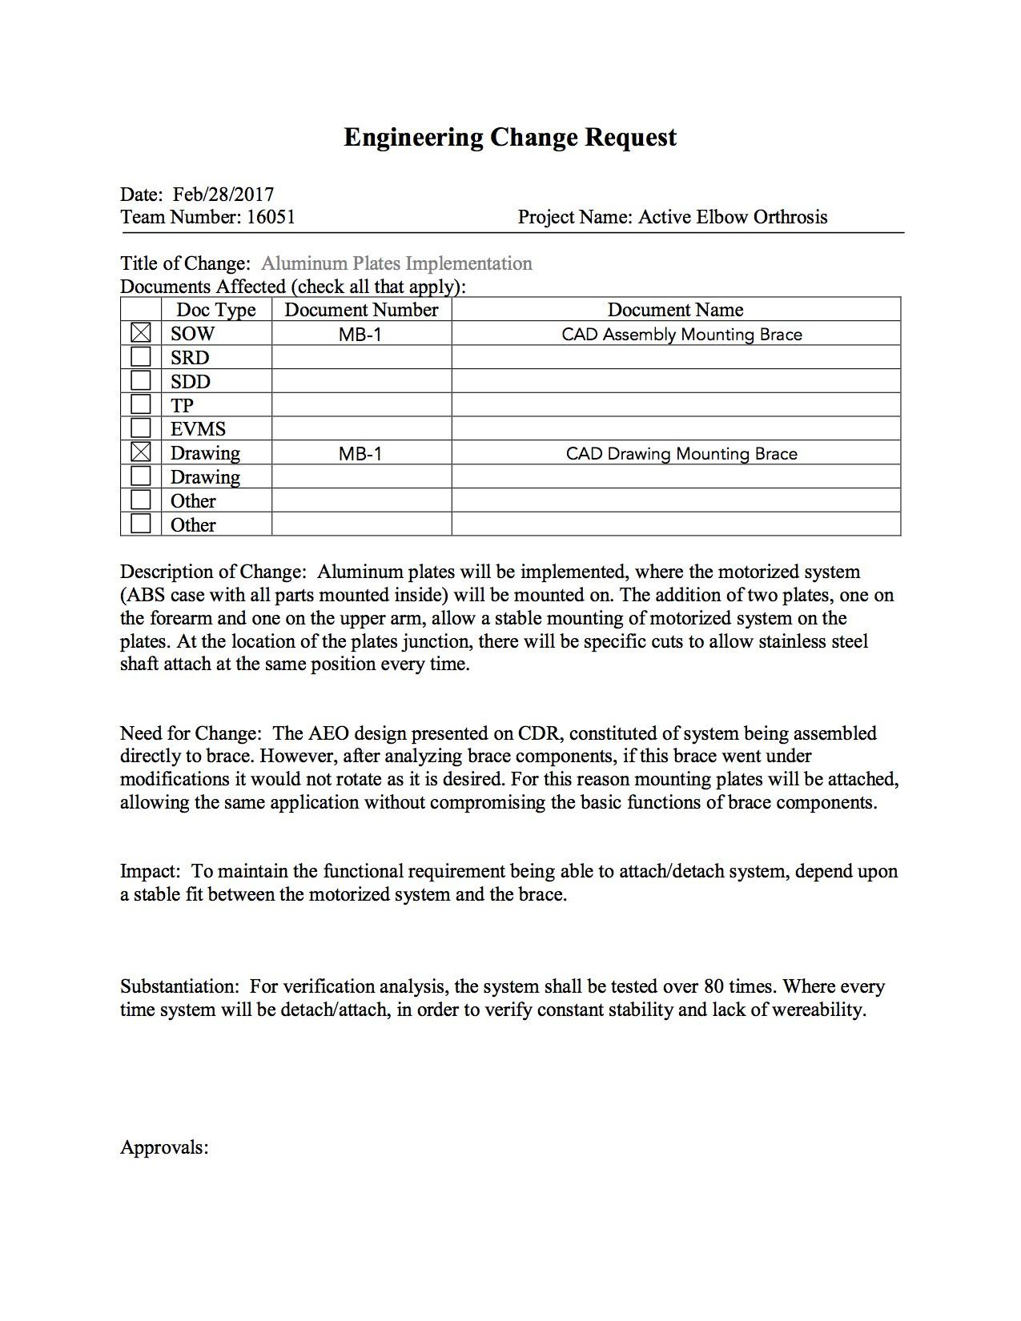

### 

### **2.0 System Block Diagram**

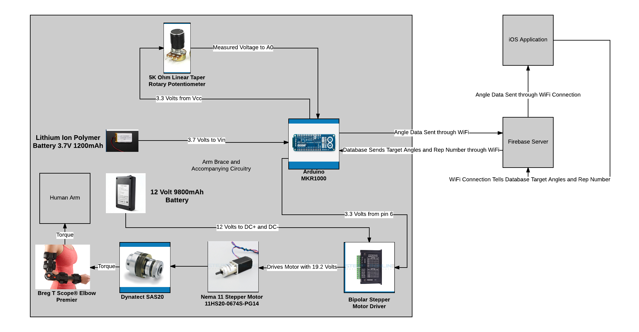

The Active Elbow Orthosis is broken up into two main distinctions: the arm brace including the mechanical and electrical components on the left and the iOS application on the right. The arm brace is composed of a Breg T Scope Elbow Premier, an Arduino MKR1000, a Nema 11 Stepper Motor, a Bipolar Stepper Motor Driver, a Dynatect SAS20 clutch, a 5K ohm potentiometer (sensor), locking pin, and a power supply consisting of a lithium ion polymer battery and a 19.2 Volt battery. The iOS application will include pages for login, schedule/calendar of exercises, exercise history, and exercise initiation.

The iOS application will interface with the patient-user. Instructions for use of the iOS application will be given in the Technical Data Package. The iOS application will connect through wifi with the Arduino MKR100. The Arduino will send the application information on the angle of the elbow brace. The application will process and store that information. Based on the application exercise schedule, the application will send instructions to the Arduino on when and to what extent the motor will act in assisting elbow flexion or extension.

The Arduino is the focal point of the arm brace electromechanical system. The Vcc pin on the Arduino will be connected to the 5K ohm potentiometer in series with a 1K ohm resistor. The GND pin of the Arduino will be connected to the other side of the potentiometer-resistor series. In between the potentiometer and the resistor, the A0 pin will read the voltage at that node and convert it to a digital signal. The A0 pin is a 12 bit analog-to-digital converter. The Arduino reads the voltage between the resistor and potentiometer and converts that voltage to an angle reading with the equation from analysis. The relationship between the voltage at the node between the resistor and potentiometer and the elbow angle is: V = 88($θ) / (1000 + 26.667 θ)$. The angle reading is sent to the iOS application through the wifi connection. The sampling rate for the ADC is 10,000 Hz, which is well above the minimum required sampling rate.

The Arduino MKR1000 is powered by the lithium ion polymer battery which will supply 3.7 volts to the Vin pin of the Arduino. The lithium ion polymer battery has 1200 mA-hours. During research on the Arduino, the minimum recommended battery size was 700 mA-hours, which means we are well beyond the minimum.

Upon instruction from the iOS application, the Arduino MKR1000 connects 3.3 volts from pin 6 to control the bipolar stepper motor driver. The bipolar stepper motor is controlled by the Arduino and powered by the 12 volt battery with 3500 mA-hours. The stepper motor driver will drive the motor with the 12 volts from the battery. The motor has a 14:1 gearbox on its end to increase torque. The end of the gearbox will interface with the Dynatect clutch to prevent motor burnout. The clutch and motor will interface with the elbow brace. Upon instruction from the Arduino the motor driver will drive the motor which will add torque at the elbow brace joint. The added torque will aid the patient in flexion and extension of the arm.

The locking mechanism is in place to prevent the patient from feeling pain. The locking mechanism is always accessible to the patient in order to lock the elbow brace in place. Upon consideration, the locking system was kept purely mechanical so that electrical failure is not a problem.

**3.0 Drawings**

Dimensions of every components needed to be taken, to ensure the device assembly. Although, some components were constructed by third parties, drawings were still needed to ensure assembly and dimensions constraints were met.

Gearbox construction needed the modification of several components, including bevel gear, ⅝ “ diameter stainless steel shaft, as well as the construction of an aluminum housing. For the design of emergency stop and device casing, all components were taken in consideration in order to minimize volume. Drawings for every component can be found in the Appendix.

**4.0 Software Design Documents**

The iOS application will control the AEO device and there are several key features that must be included in its programming. There will be a login feature for each the patient and the physician. There will be a schedule/calendar of the patient’s exercises. The application will contain a log of the patient’s previous exercise history. The application will contain a start and stop button for the patient to begin and end an exercise. A timer will track how long the patient has been doing a given exercise. Only the physician will be able to make changes to the exercise schedule of the patient via the physician login. It is required that the application is able to communicate with the microcontroller. The application will be written in English. It has not yet been determined how much storage the application will require on a phone, since it is still undergoing development.

The iOS application sends the user-inputted values for target angle and rep number to a Firebase server via Wi-Fi. From the Firebase server, the inputted values are sent to the Arduino via Wi-Fi. Once the reps have been performed, the Arduino then sends the angle data to the Firebase server via Wi-Fi, which then relays the data back to the iOS application via Wi-Fi. The design architecture of the system is located below:

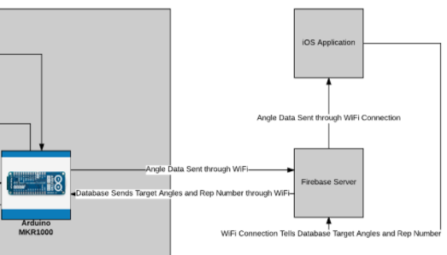

Interface Design:

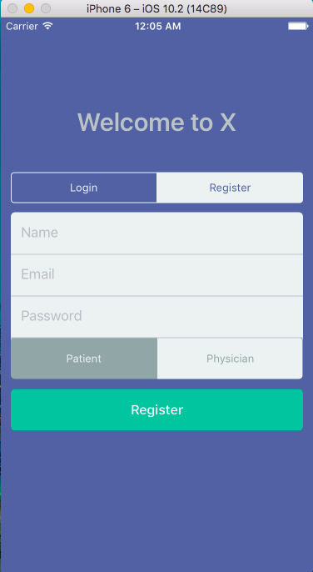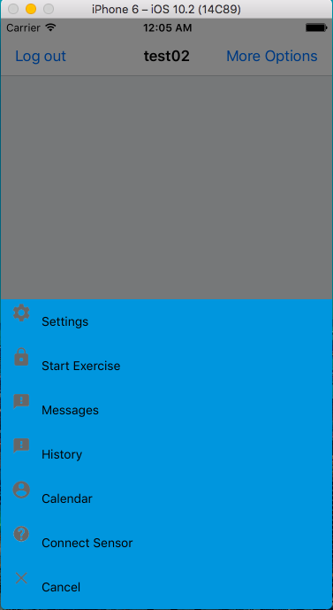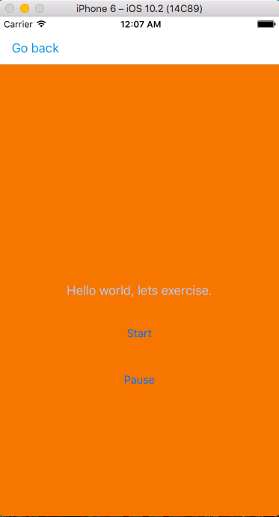

**5.0 Acceptance Test Procedure**

**ATP Introduction:**

The purpose of this Acceptance Test Plan and set of procedures is to establish the overall approach, testing sequence, and specific tests to be conducted to demonstrate successful operation of the AEO prototype. The AEO prototype provides the user with an advanced toolset for maintaining the range of motion post surgery with a state-of-the-art iPhone application. The plan and procedures described in this document are designed to verify stable and safe operational performance of the AEO prototype.

**4.1 Test Procedure Verification and Data Sheet: AEO Lock (1.0)**

Test Description: This test will verify that the AEO lock will be able to withstand a substantial amount of weight for a specific period of time.

Procedure:

1. The device shall either be worn by a healthy individual, or tightly secured so that the arm attachment is vertical and the forearm attachment is horizontal
2. The lock shall be applied to keep the AEO fixed at the 90˚ angle
3. A 30 lb weight (+/- 1 lb) shall be suspended from the forearm attachment 6 inches (+/- 0.2 inches) from the hinge
4. A chronometer will be used to time the duration of the weight suspension
5. The brace shall withstand this amount of weight for 15 seconds

Diagram:

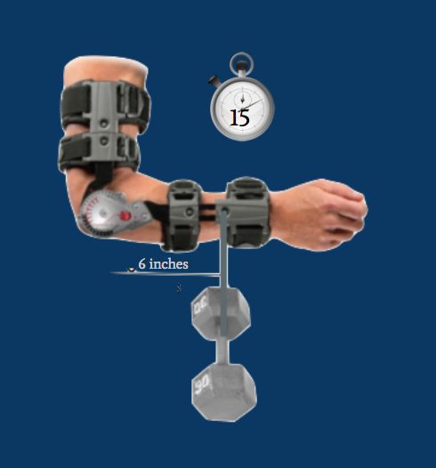

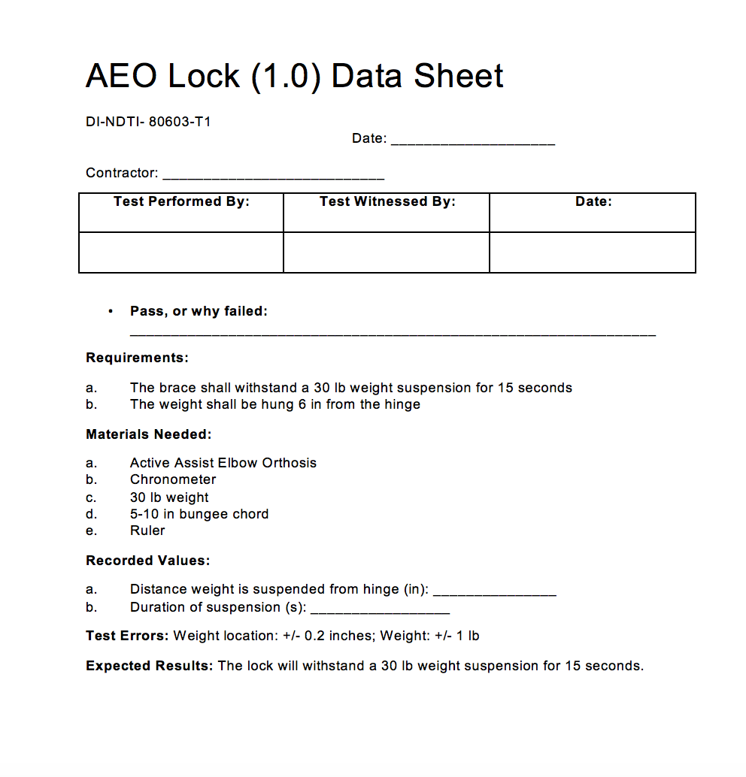

**4.2 Test Procedure Verification and Data Sheet: Motor Torque (2.0)**

Test Description: This purpose of this test is to verify that the motor is able to actively assist the patient in movement as the patient exhibits a certain amount of resistance. The weights will be used to mimic this resistance, and the motor should flex and extend the brace in less than 15 seconds.

Procedure:

1. The upper section of the AEO device shall be fixed in a vertical position.
2. With iOS app, motor shall be instructed to perform flexion movement, from around 0° to 120°
3. With iOS app, motor shall be instructed to perform extension movement, from around 120° to 0°
4. A chronometer will be used to measure the time it takes for the device to move from 0˚ to 120˚, which should be less than 15 seconds. The chronometer will be used to measure the time it takes the device to move from around 120˚ to 0˚, which should also be under 15 seconds.
5. Step 2 and 3 shall be repeated by adding no weight, followed by 1 kg weight (+/- 0.1 kg) added 3 inches from the hinge on the forearm attachment, and 4 kg weight (+/- 0.1 kg) attached 3 inches (+/- 0.2 inches) from the hinge on the forearm attachment.
6. The chronometer will be used to measure these times the device will flex and extend, which will be under 15 seconds each way.

Diagram: 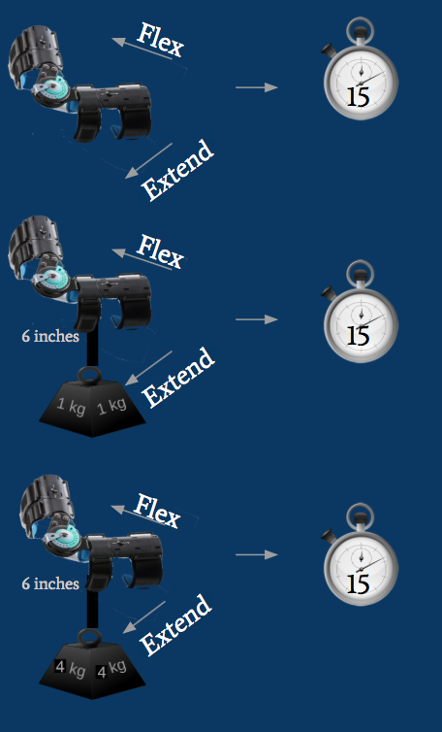

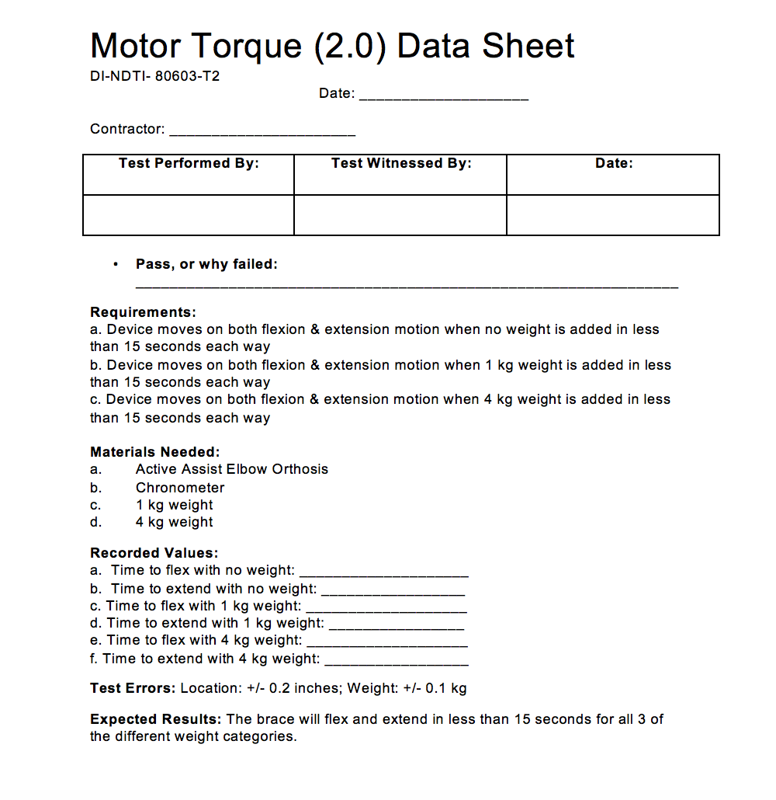

**4.3 Test Procedure Verification and Data Sheet: Position Tolerance (3.0)**

Test Description: The purpose of this test is to verify that the device moves to the correct position that it is instructed to via the iOS application. The position of the brace is necessary to further verify that the sensor works correctly.

Procedure:

1. The device shall be securely worn on a healthy individual, and powered on via iOS app
2. The subject will instruct the device to move to desired angle (45˚) via iOS app
3. Once the device stops at the instructed angle, an exacta goniometer will be used to measure the angle
4. Add collected data to the data sheet
5. If the angle measured is within 2.5˚ of the desired angle, the device passes the test

Diagram:

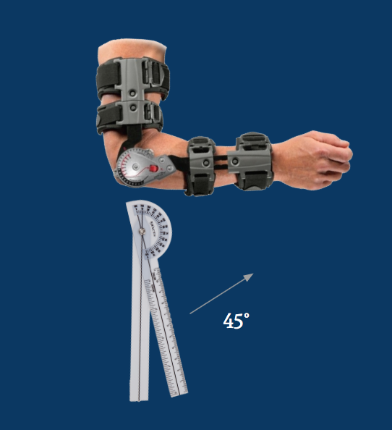



**4.4 Test Procedure Verification and Data Sheet: AEO Sensor (4.0)**

Test Description: The purpose of this test is to ensure that the AEO sensor works at a variety of angles, and reads within 2.5˚ of the desired angle.

Procedure:

1. The device shall be securely worn on a healthy individual, and powered on via iOS app
2. The subject will instruct the device to move to desired angle (45˚)
3. Once the device stops at the instructed angle, an exacta goniometer will be used to measure the angle
4. The angle will be recorded on the data sheet
5. The subject will instruct the device to move to desired angle (60˚)
6. Steps 3 and 4 are repeated
7. The subject will instruct the device to move to desired angle (120˚)
8. Steps 3 and 4 are repeated
9. If the angle measured is within 2.5˚ of the programmed angle, the device passes the test

Diagram: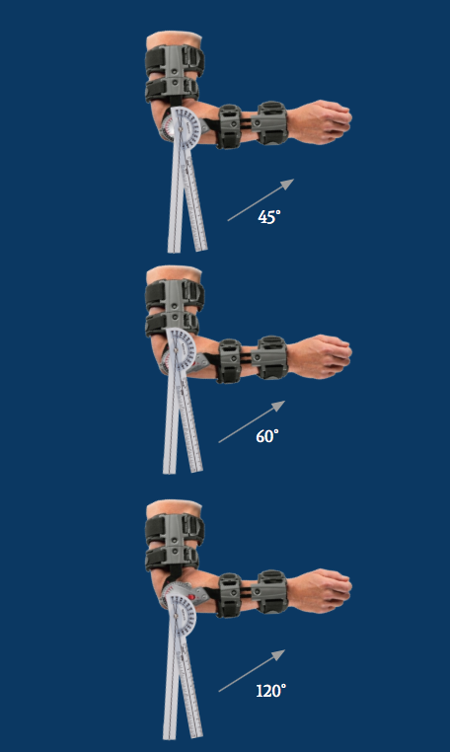

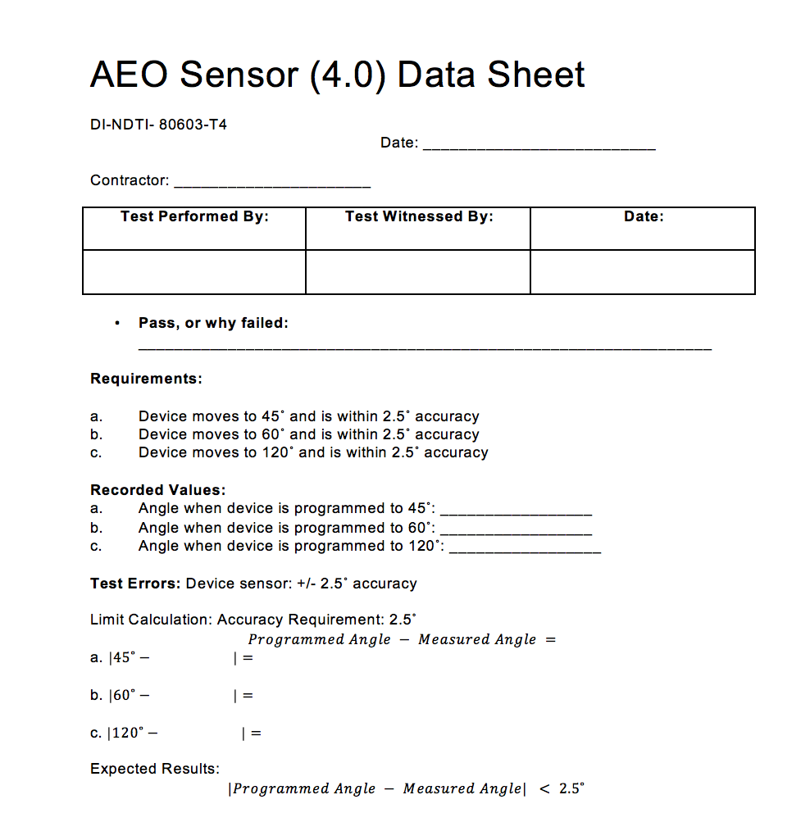

**4.5 Test Procedure Verification and Data Sheet: Angular Speed (5.0)**

Test Description: The purpose of this test is to verify that the flexion and extension movement has a rotational speed of less than 10˚ per second.

Procedure:

1. The device shall be securely worn on a healthy individual, and powered on via iOS app
2. The AEO device shall be commanded by the app to move from around 0° to 120°. The patient shall not exert any external force.
3. With the use of a chronometer, the time shall be measured accurately.
4. Step 2 and 3 shall be performed now extending the arm, from 120° to 0°.
5. Equation to calculate the rotational speed is ω=120/t , t being time in seconds.

Diagram:

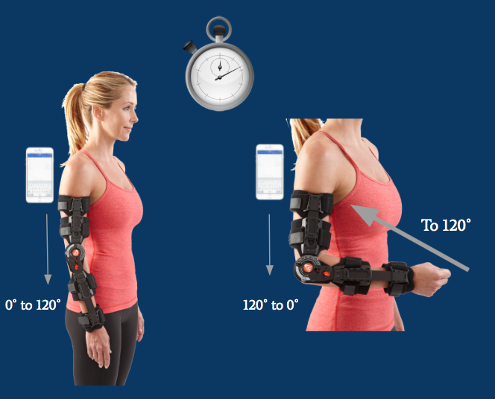

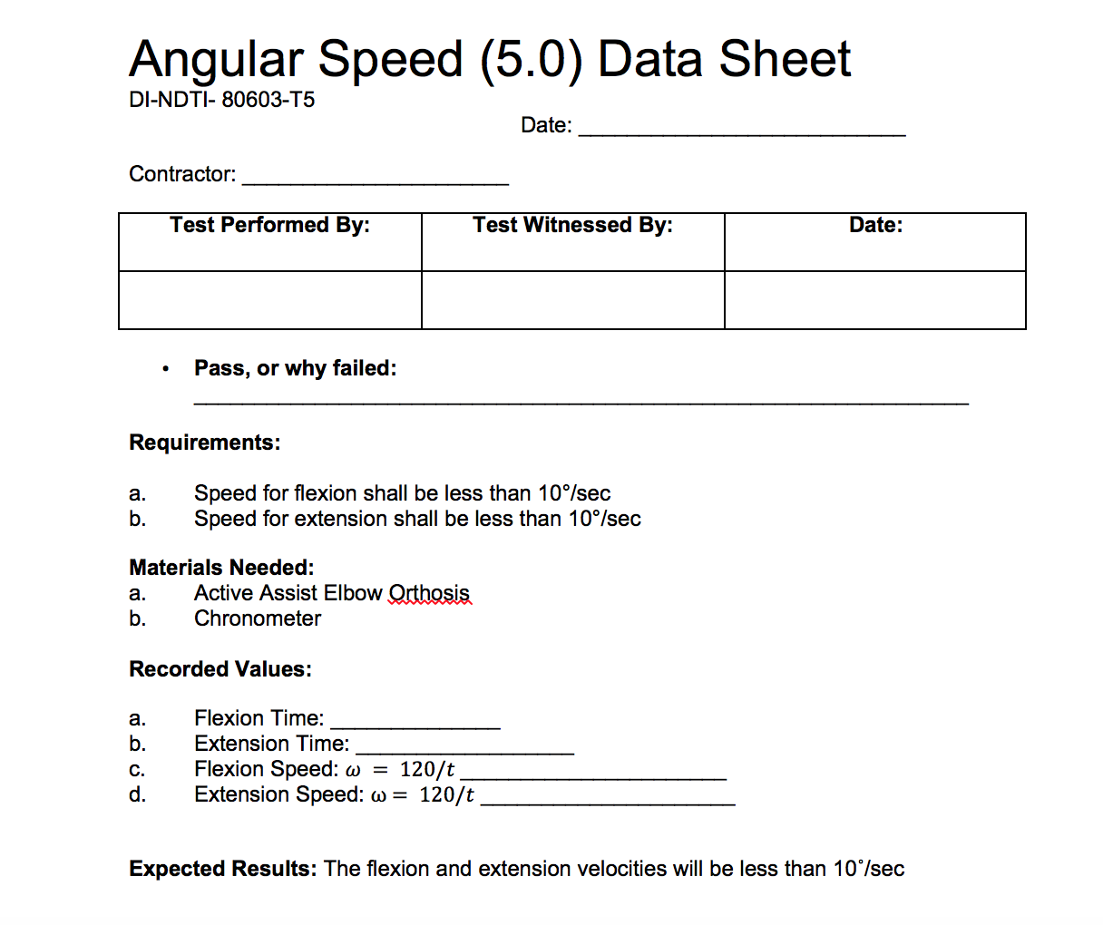

**4.6 Test Procedure Verification and Data Sheet: Sensor App Accuracy (6.0)**

Test Description: The purpose of this test is to verify that the sensor on the AEO device will measure the angle of the elbow within 2.5˚ of the actual angle. It is necessary to test that the measurements at full extension and full flexion are within 2.5˚ of the actual angle to ensure the device is capable of accurately moving within a healthy individual’s full range of motion.

Procedure:

1. A healthy individual will use the brace for angle measurements at **maximum extension** and **maximum flexion**.
2. The individual test subject will fully extend their elbow while wearing the AEO
3. iOS application shall display the angle of extension within 2.5˚ of the actual angle
4. Exacta goniometer shall measure the angle to verify the app reads within 2.5˚ of the actual angle
5. Record sensor accuracy on data sheet
6. Test subject will fully flex their elbow while wearing the AEO
7. iOS application shall display the angle of flexion within 2.5˚ of the actual angle
8. Exacta goniometer shall measure the angle to verify the app reads within 2.5˚ of the actual angle
9. Record sensor accuracy on data sheet

Diagram:

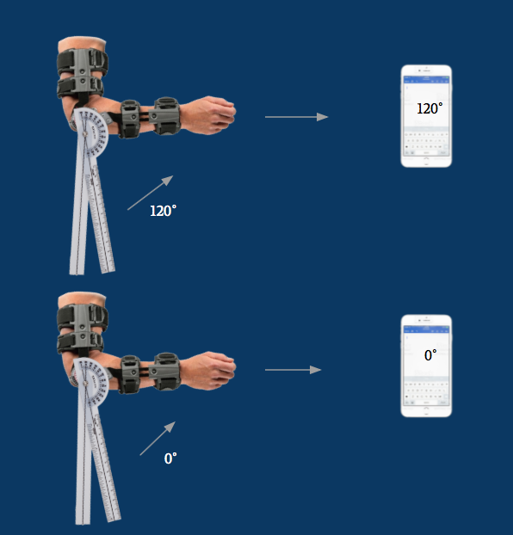

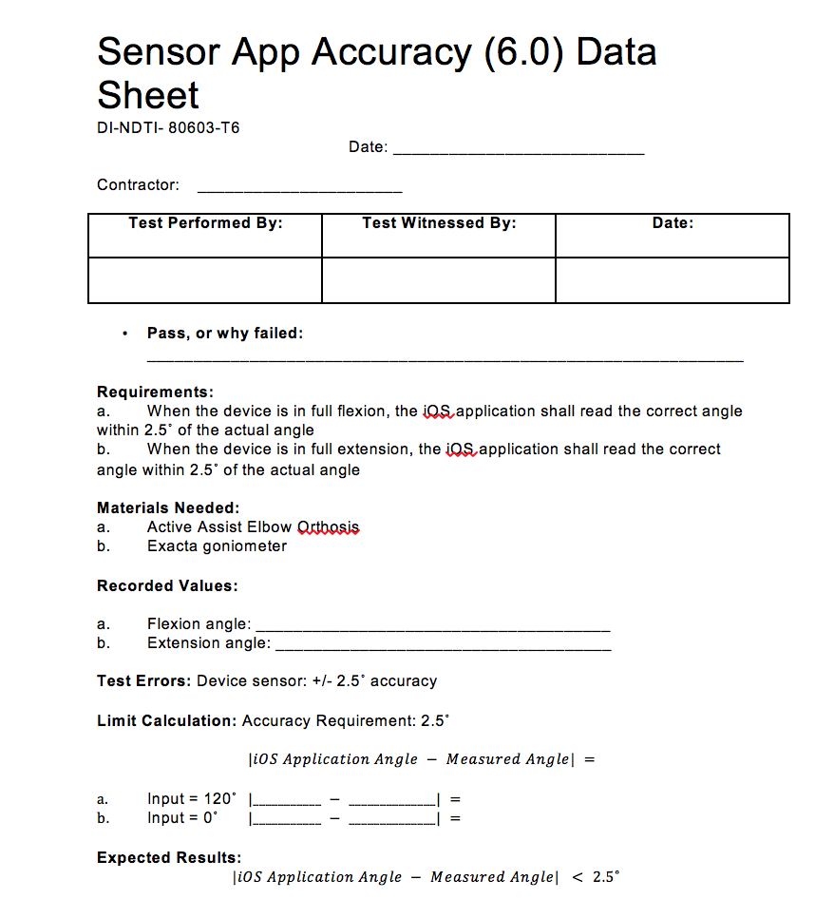

**4.7 Test Procedure Verification and Data Sheet: Temperature Range (7.0)**

Test Description: The purpose of this test is to verify that the entire AEO device can withstand extreme temperatures and still operate a full range of motion in less than 15 seconds.

Procedure:

1. Place the AEO inside a preprogrammed refrigerator set to 32˚F (0˚C)
2. Set a timer for 30 minutes
3. Remove the AEO from the refrigerator and begin testing within 5 minutes of removal
4. Power on the AEO using the iOS application, and program the AEO to move the full 120˚ range of motion in less than 15 seconds.
5. Let the AEO come to room temperature
6. Place the AEO inside a preheated oven set at 104˚F (40˚C)
7. Set a timer for 30 minutes
8. Remove the AEO from the oven and begin testing within 5 minutes of removal
9. Repeat Step 4
10. Record the pass/fail results in the data sheet

Diagram:

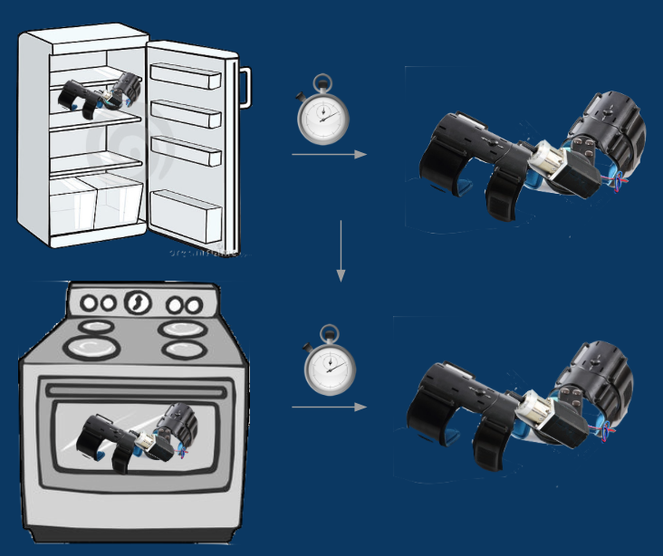

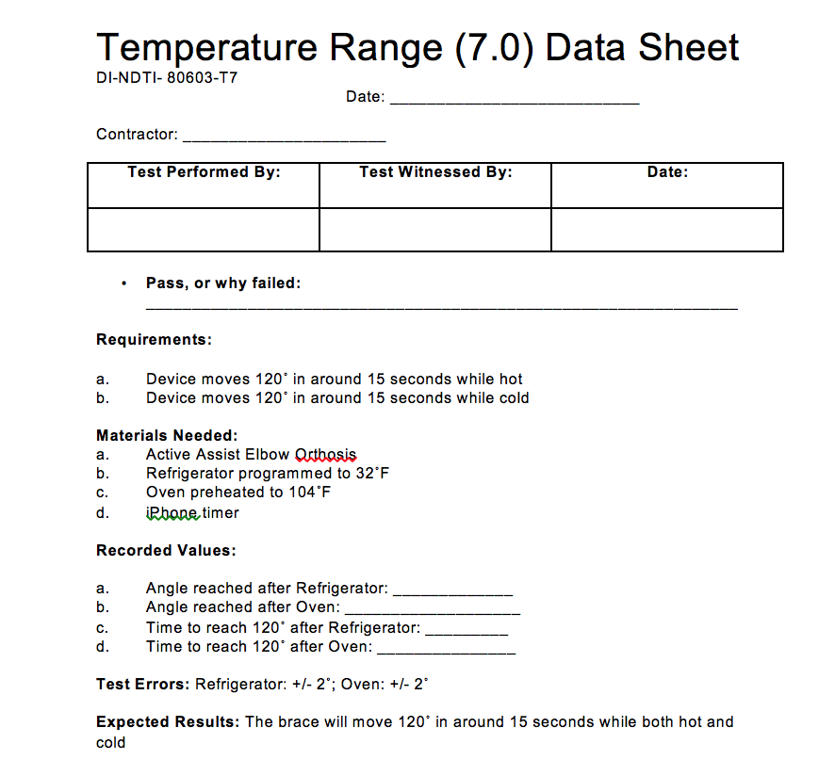

**4.8 Test Procedure Verification and Data Sheet: Weather (8.0)**

Test Description: The purpose of this test is to mimic a light rainy condition and verify that the AEO device can operate under such weather conditions.

Procedure:

1. Fill a squirt bottle with water
2. Lay the AEO on an empty, flat surface
3. Make sure casing is attached with motor not visible to water
4. Spray the device 5 times beginning at one end of the AEO, and slowly spraying to the other end of the AEO
5. Power on the AEO using the iOS application, and program it to move the full 120˚ range of motion in 15 seconds or less
6. Use chronometer to measure the time of the movement
7. Record the pass/fail results of the AEO moving with the water droplets mimicking light rain into the data sheet

Diagram:

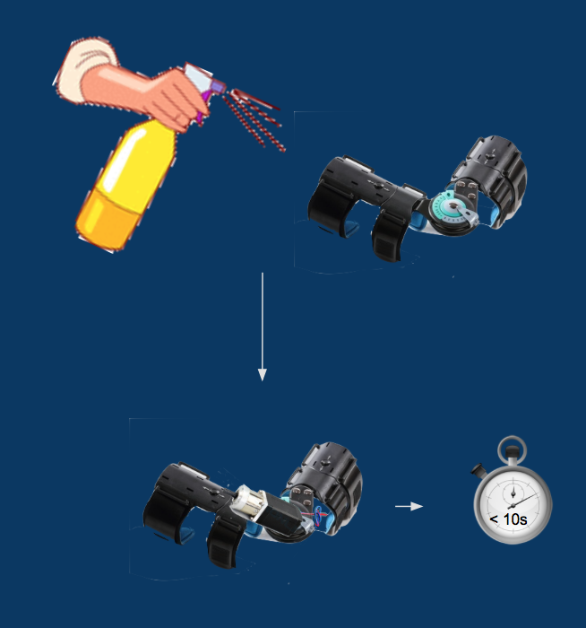

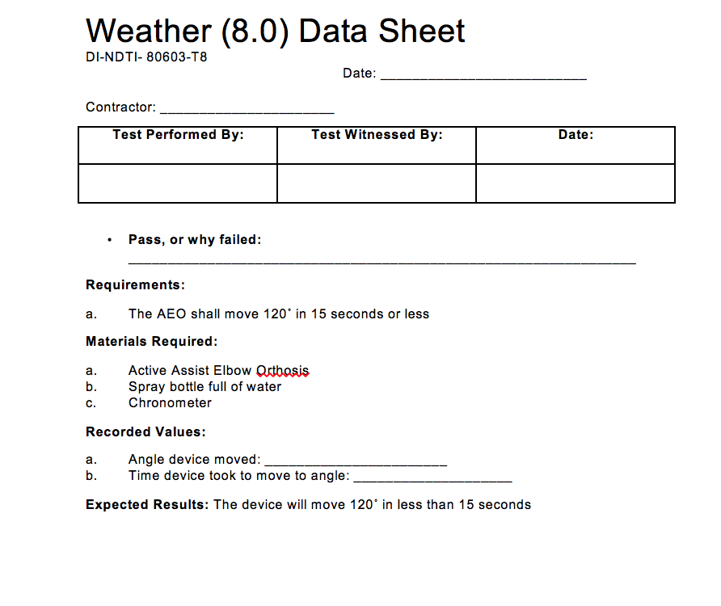

**4.9 Test Procedure Verification and Data Sheet: Battery Life (9.0)**

Test Description: The purpose of this test is to ensure that the AEO device can operate at least 20 cycles before the battery dies. The user should be able to perform at least two full exercises during the lifetime of the battery.

Procedure:

1. Attach the 12V battery, motor, and casing unit onto the brace, and power the device on via the iOS application
2. Program the device to flex from 0˚ to 120˚ and to extend from 120˚ to 0˚
3. Perform this movement as many times until the battery is completely dead
4. Use an iPhone timer to determine the duration of battery life. Begin the timer as soon as the first flexion movement begins. Battery life should last at least an hour
5. The device shall flex and extend to complete one cycle, and a total of 20 cycles should be completed before the battery dies
6. Record the number of complete cycles that occur on the data sheet
7. If the device completes at least 20 cycles in the battery life, it passes the test

Diagram:

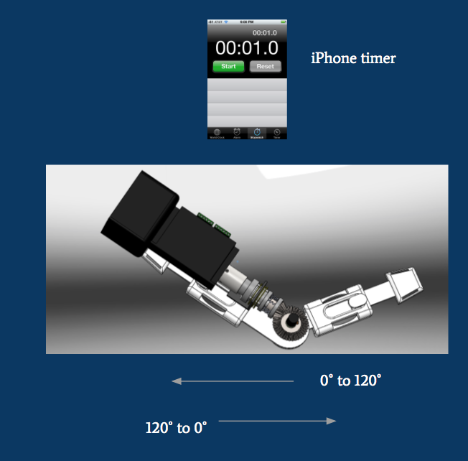

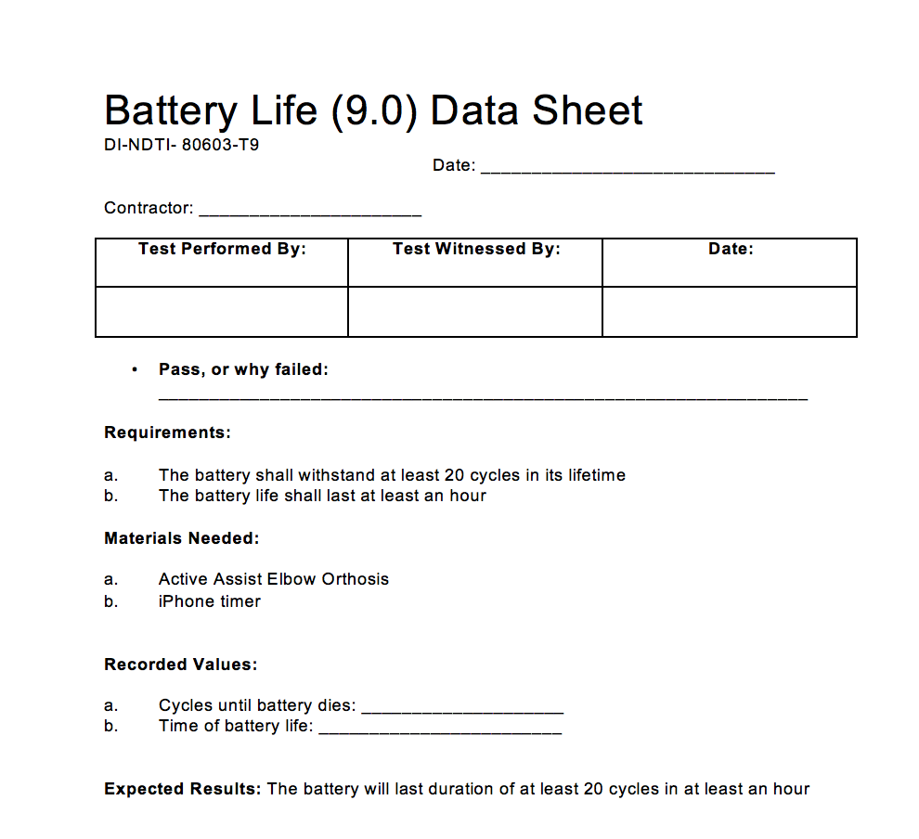

**4.10 Test Procedure Verification and Data Sheet: Battery Recharge (10.0)**

Test Description: The purpose of this test is to verify that the time it takes the battery to recharge is less than 5 hours. This way, the user will be able to perform his/her exercises multiple times a day.

Procedure:

1. Run the 12V battery until it is completely dead.
2. Plug the battery into the charging dock in the nearest outlet
3. Using an iPhone timer, time the duration it takes for the battery to be fully recharged
4. Battery recharge time should take less than 12 hours for the device to pass.
5. Record time on the data sheet

Diagram:

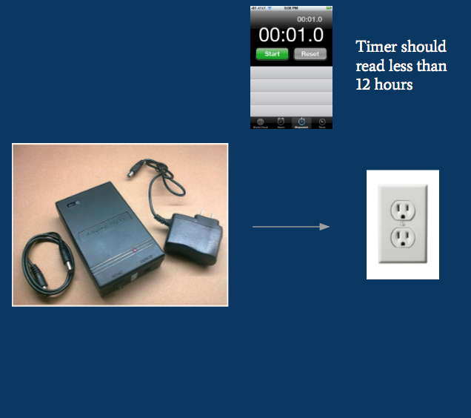

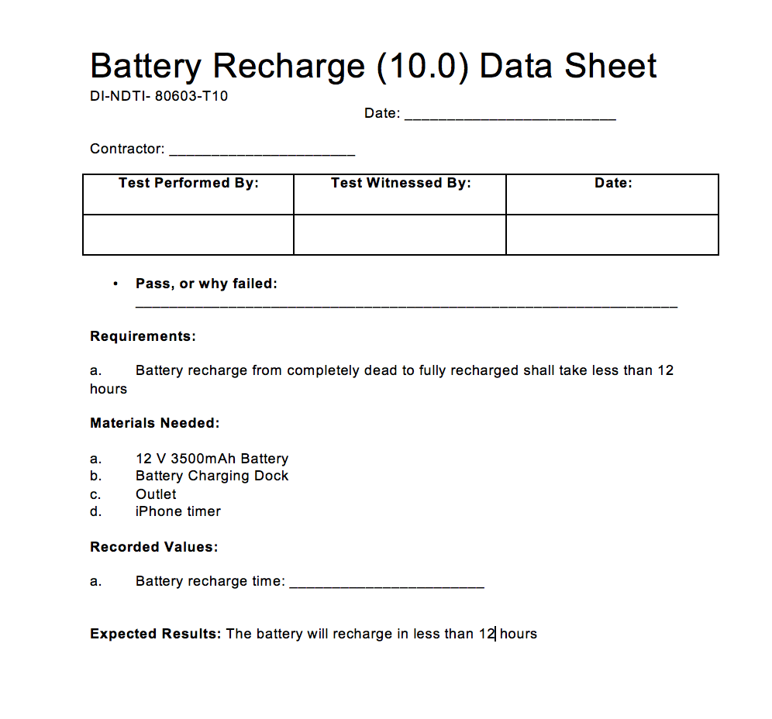

**6.0 Models and Analyses**

All images and calculations in the Models and Analyses can be found in the Appendix to accompany the respective descriptions below.

**6.1 Torque Model**

The torque model was used to analyze the amount of torque exerted by the arm muscles at each angle of flexion from 0 to 120 degrees. It was found that there was a maximal torque of 345 N-cm exerted at 96 degrees. This model helped us determine how much torque our brace should exert. We do not want the device to exert the full amount, but rather, somewhere around half the maximum torque. The information gathered was key in helping us to pick out the motor.

**6.2 Motor Power Model**

The battery capacity needed for the motor operation was calculated by first finding the operating time and then multiplying that time by the current needed to run the motor. The operating time was determined as the time required to complete 20 cycles of full 120 degree flexion at 10 degrees per second. The maximum current that can be run into the motor is 0.67 amps. The battery capacity required for one exercise (20 cycles) is 55.8 mAmp-Hrs.

**6.3 Sensor Model**

The relationship between the voltage read by pin A0 of the Arduino MKR1000 is the voltage between the 5K ohm potentiometer and the 11K ohm resistor. That voltage depends on the resistance of the potentiometer. The resistance of the potentiometer is dependent on the turning of its knob. To calibrate the sensor, use the two calibration points. Record two angles of the brace with the corresponding resistances of the potentiometer. The two data points will be written into the Arduino code. The Arduino code will create a linear equation and use the potentiometer slope (called PotSlope) and potentiometer intercept (called PotIntercept) to find the angle of the brace given the voltage at the node between resistor and potentiometer. The circuit is set-up as a voltage divider. The input voltage is

3.3 V from the Arduino. The relationship between the voltage at the node between the resistor and potentiometer and the resistance of the potentiometer is: V = 3.3 R / (11000 + R). Substituting the relationship between potentiometer resistance and elbow angle, we can obtain a relationship between sensor voltage and angle of the elbow. The Arduino uses the following code: AngleValue = (((SensorVoltage * R1) / (3.3 - SensorVoltage)) - PotIntercept) / PotSlope;.

**6.4 Weight Analysis**

The weight analysis for the AEO is broken-down into the weight of each part utilizing excel as a tool. It is analyzed and verified that the AEO device, entailing all its individual parts and casing, will weigh less than ten pounds. The breakdown of this is shown in Appendix 10.3.

**6.5 Temperature Analysis**

Excel is used as a tool to analyze the lowest and highest operating temperatures for each individual part. This analysis allows us to determine at which temperatures the AEO device shall be operational. According to this, the battery is the limiting part when measuring temperature due to the fact that it has the highest low operating temperature and the lowest high operating temperature. In result, the range of operating temperature is from 32 degrees Fahrenheit to 104 degrees Fahrenheit. The temperature analysis range is broken down in the table shown in Appendix 10.3.

**6.6 Sensor Analysis**

The maximum voltage to be read at the A0 pin of the Arduino MKR1000 is 2.75 V and the minimum is 0 V. The maximum error in degrees is 2.5. The smallest degrees/division is that 2.5 degrees. Because of the 12 bit ADC of pin A0, the degrees per division is 0.0366, which is much better than necessary.

**6.7 Step Angle Analysis**

The step angle analysis was simple. The maximum error for the AEO motor movement is 2.5 degrees, therefore, the largest step size for our motor would be 2.5 degrees per step. The NEMA 11 stepper motor that we chose has a 0.131 step angle, which is much better than the 2.5 step angle required.

**6.8 Sampling Analysis**

The target angular velocity for the AEO is 10 degrees per second. At 10 degrees per second angular velocity, the sensor would have to sample every 0.25 seconds in order to stay within that 2.5 degree accuracy required. A 4 Hz sampling rate is required at 10 degrees per second. The likely maximum angular velocity that the AEO would exhibit is 1500 degrees per second. In order to stay within that 2.5 degree accuracy, the sensor would need to sample every 0.001667 seconds, which is 600 Hz. According to the [www.arduino.cc](http://www.arduino.cc) site, the sampling rate of the Arduino MKR1000 is 10,000 Hz, which is well above what is necessary.

**7.0 Acceptance Test Results**

The following are the recorded results from each of the ten tests that were performed in order to satisfy the functional requirements of the AEO device. Each one is completed, with a 95% pass rate, and signed by the sponsor of the device.

**7.1 Test Results: AEO Lock (1.0)** 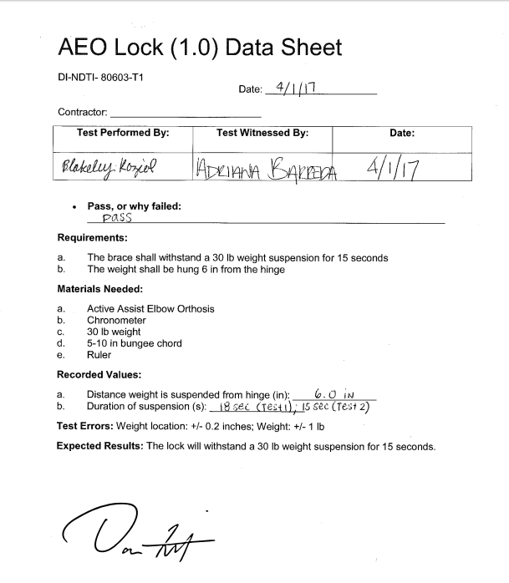

**7.2 Test Results: Motor Torque (2.0)**

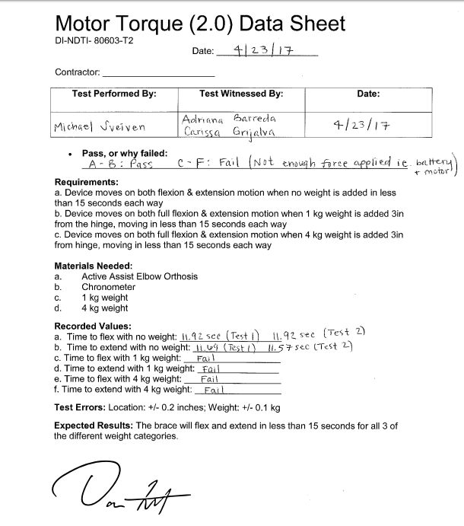

**7.3 Test Results: Position Tolerance (3.0)**

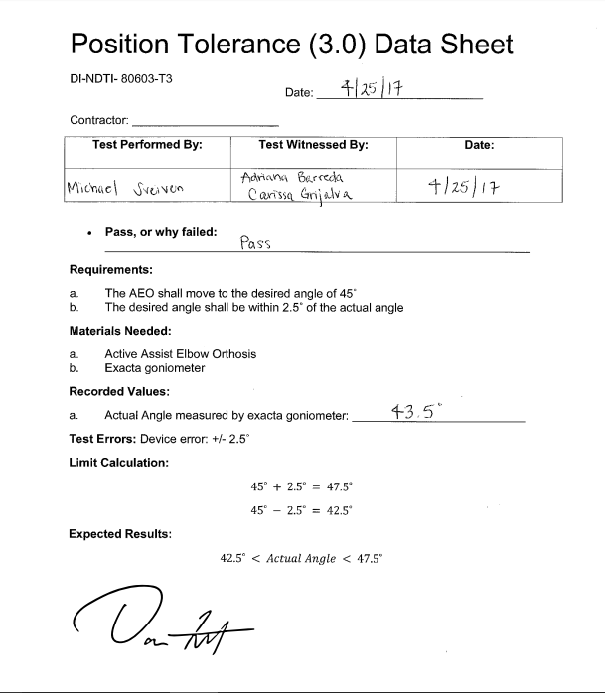

**7.4 Test Results: AEO Sensor (4.0)**

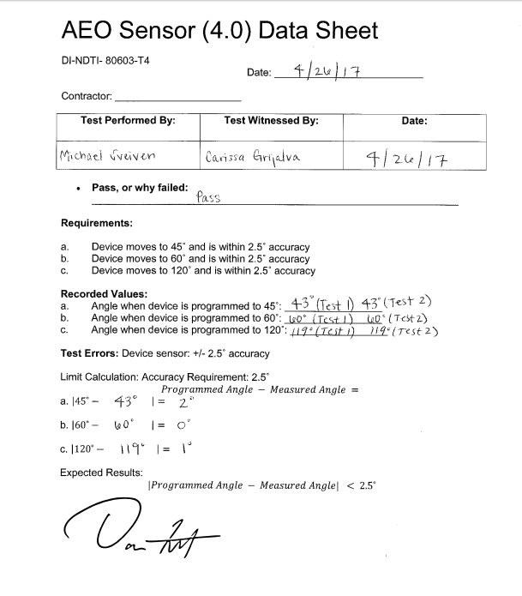

**7.5 Test Results: Angular Speed (5.0)**

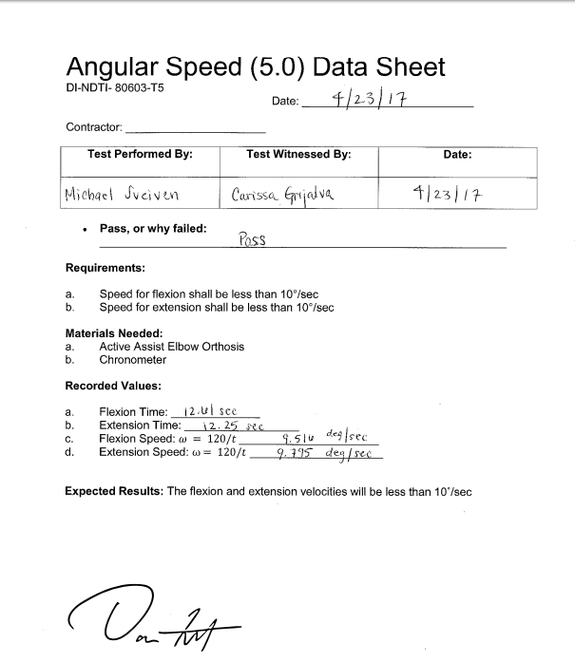

**7.6 Test Results: Sensor App Accuracy (6.0)**

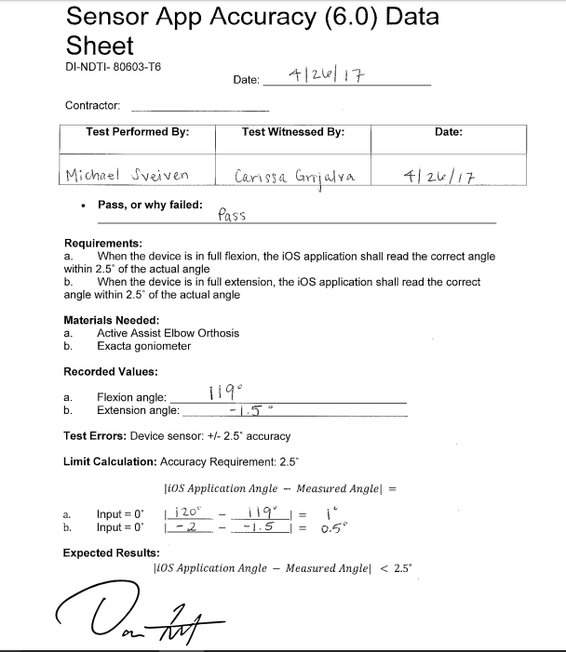

**7.7 Test Results: Temperature Range (7.0)**

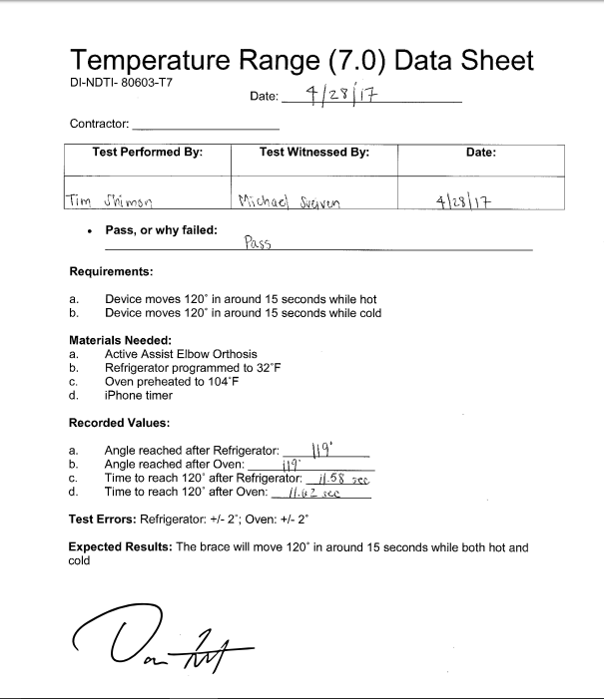

**7.8 Test Results: Weather (8.0)**

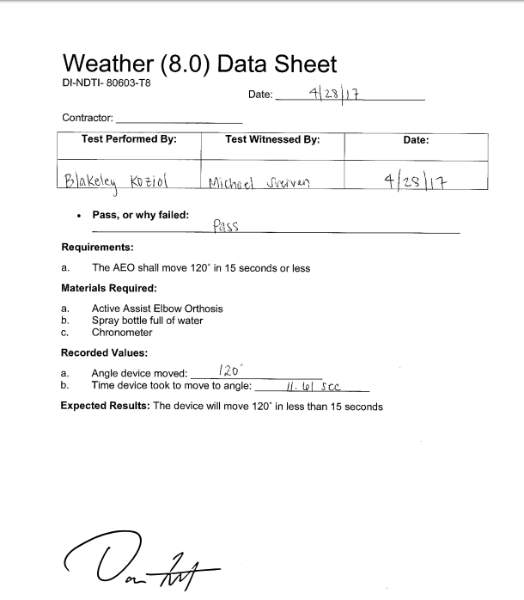

**7.9 Test Results: Battery Life (9.0)**

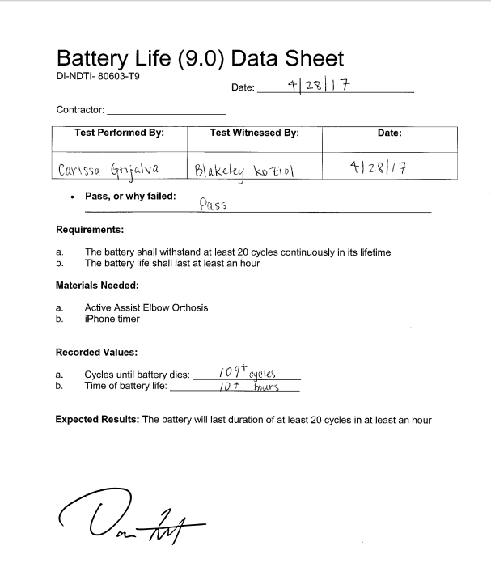

**7.10 Test Results: Battery Recharge (10.0)**

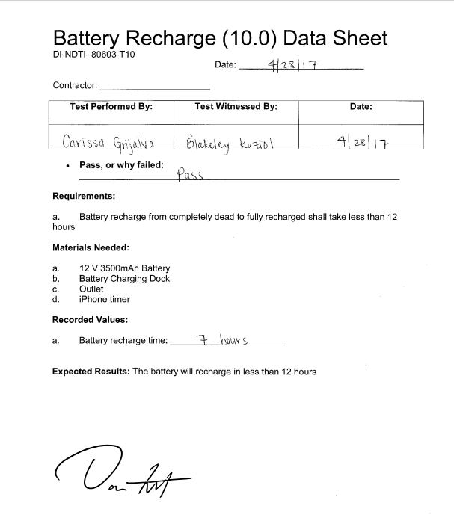

**8.0 Final Budget**

The total final budget cost for the AEO project is $3,236.18. This cost includes each ordered, or assembled/machined part, the consultant, the poster, team shirts, and outside casing materials. This is also taking into account the the physical brace was donated from the sponsor, which will not be the case for future generations. The total budget offered was $4,000, thus the team was well under the given budget. The following is a table that summarizes the cost for each part.

|  |  |  |  |
| --- | --- | --- | --- |
| Item | Cost Ea. | Qty. | Used in project |
| Arduino | $36.95 | 1 | Yes |
| Potentiometers | $8.13 | 5 pc. | Yes |
| Stepper Motor (including gear box) | $50.92 | 1 | Yes |
| Arduino Battery | $17.95 | 1 | Yes |
| Motor Battery and converter | $36.97 | 1 | Yes |
| Brace | Free | 1 | Yes |
| Stepper Motor Driver | $34.69 | 1 | Yes |
| Slipper Clutch | $102.70 | 1 | Yes |
| Boston Gear Spiral Bevel Gear | $33.51 | 1 | Yes |
| Boston Gear Spiral Bevel Pinion Gear | $21.80 | 1 | Yes |
| Petg Casing | $288.69 | 1 | Yes |
| Velcro tape | $9.99 | 1 | Yes |
| Screws | $7.29 | 6 pc. | Yes |

|  |  |  |  |
| --- | --- | --- | --- |
| Item | Cost Ea. | Qty. | Used in project |
| Motor Mounting Bracket | $17.44 | 2 | Yes |
| 2 Steel Shafts | $42.87 | 1 | Yes |
| Ball Bearing | $15.10 | 2 | Yes |
| Small Ball Bearing | $5.77 | 1 | Yes |
| Bushing Bearing | $1.26 | 1 | Yes |
| Gearbox: aluminum material | $20.45 | 1 | Yes |
| Machine Shop Labor | $500.00 | N/A | Yes |
| Team Shirts | $18.35 | 7 | Yes |
| Student Consultant | $1000.00 | 1 | Yes |
| Design Day Poster | $140.00 | 1 | Yes |
| Motor battery | $27.14 | 1 | Extra |
| Arduino battery | $14.97 | 1 | Extra |
| Total | $3236.18 |  |  |

**9.0 Lessons Learned**

Throughout the year, all team members made significant improvements as Engineers in training. Our ability to learn from mistakes was crucial, especially because so many mistakes were made.

One lesson we learned was about the difficulties that arise when we make assumptions. For example, when we ordered our rotary linear potentiometer to act as a sensor, we assumed that the relation between angle and resistance will be perfectly linear. In reality, the relation was linear, but there was some deviations, especially near the limits of the potentiometer. We had to conduct analyses of the relationship of angle and resistance, which enabled us to discover the range of the potentiometer where the relationship is suitably linear.

Another lesson and perhaps the most important was that resourcefulness is crucial to success, particularly when we were working on topics that are not within our expertise. For example, when creating an iOS application, we sought the assistance of Mario Hernandez, a computer science student at the University of Arizona. Also, when creating our gear train, we sought help from Justin Peery, a Raytheon engineer.

In addition, we learned how to maintain deadlines. After setting deadlines, it is easy to let teammates let deadlines slide. But in order to stay on schedule, it is vital that all teammates hold each other accountable, even with tasks that do not seem critical.

Finally, the team learned to plan for setbacks. Problems will occur and mistakes will be made that will push cause the schedule to be delayed. For example, 3D printing caused some setbacks when the measurements did not fit between the brace and the case. Also, in regards to the software, large problems arose from small mistakes in the software. In order to deal with the inevitable setbacks, give extra time to account for mistakes and unforeseen problems.

**10.0 Appendices**

**10.1 Drawings PDFs**

1. **Plates Drawing**

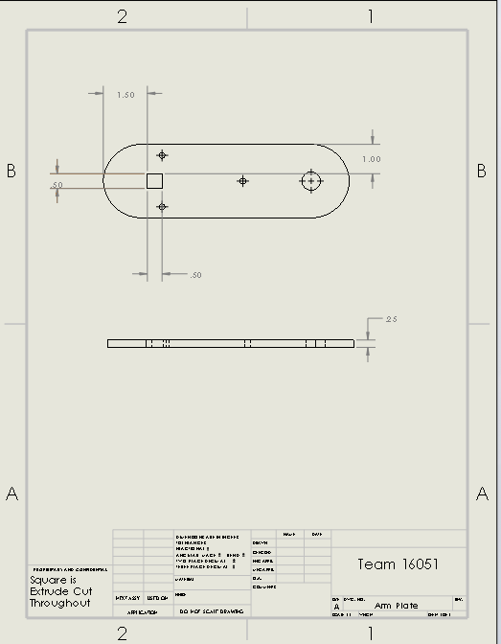

**2. Gearbox housing Drawings**

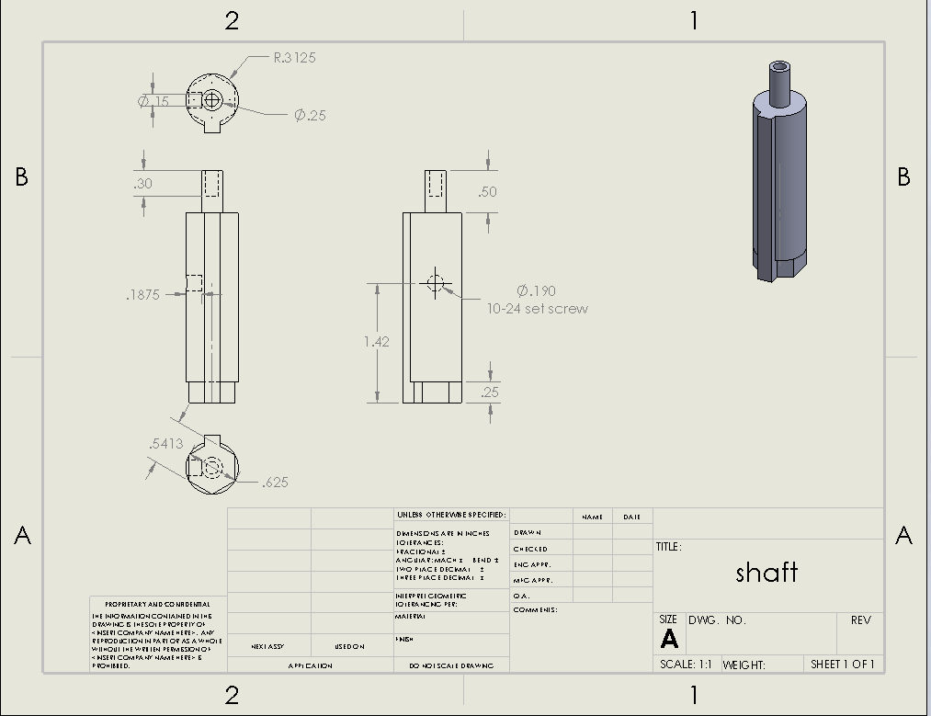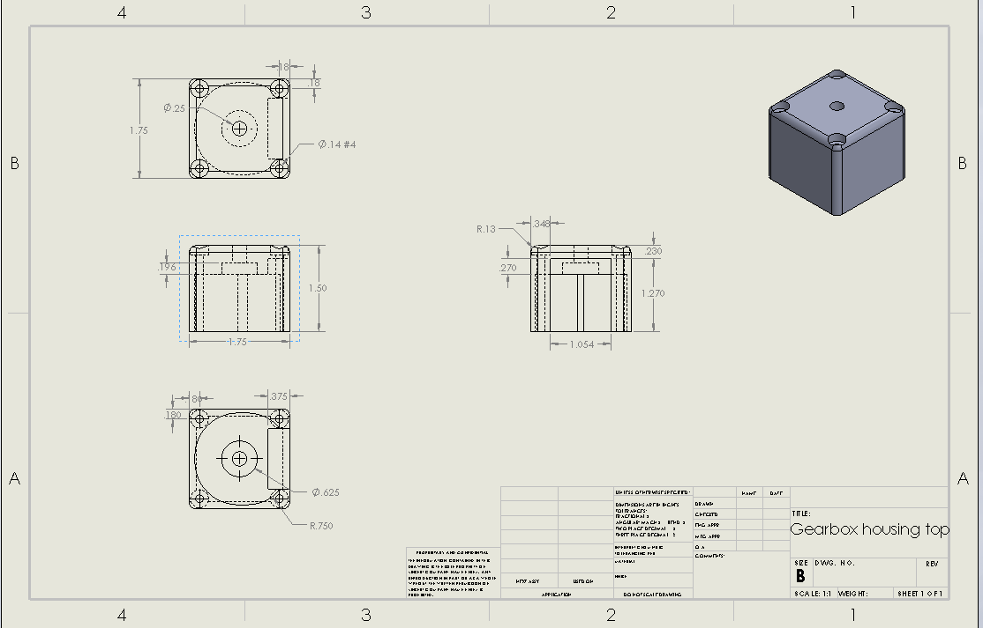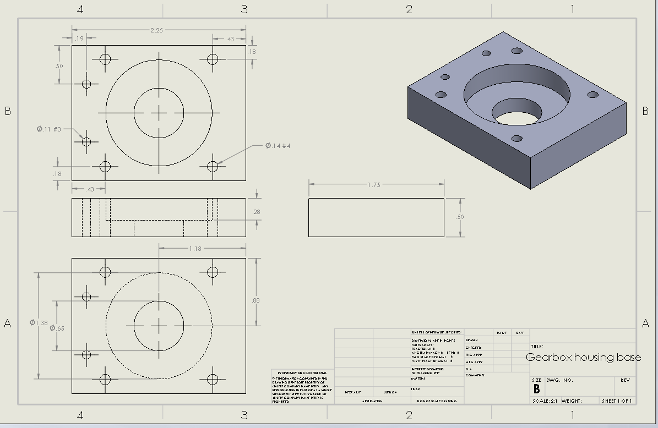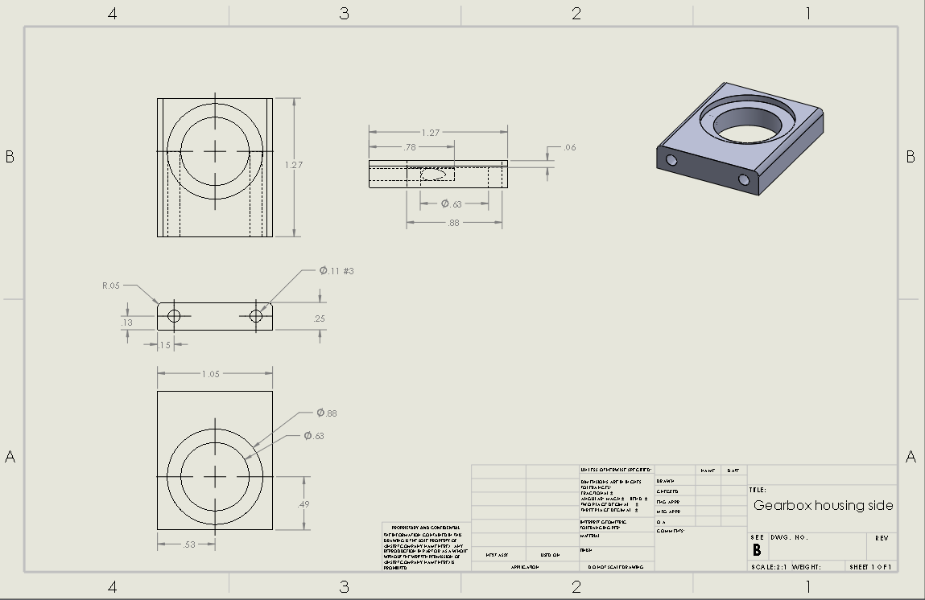

**1. AEO Assembly Drawing**

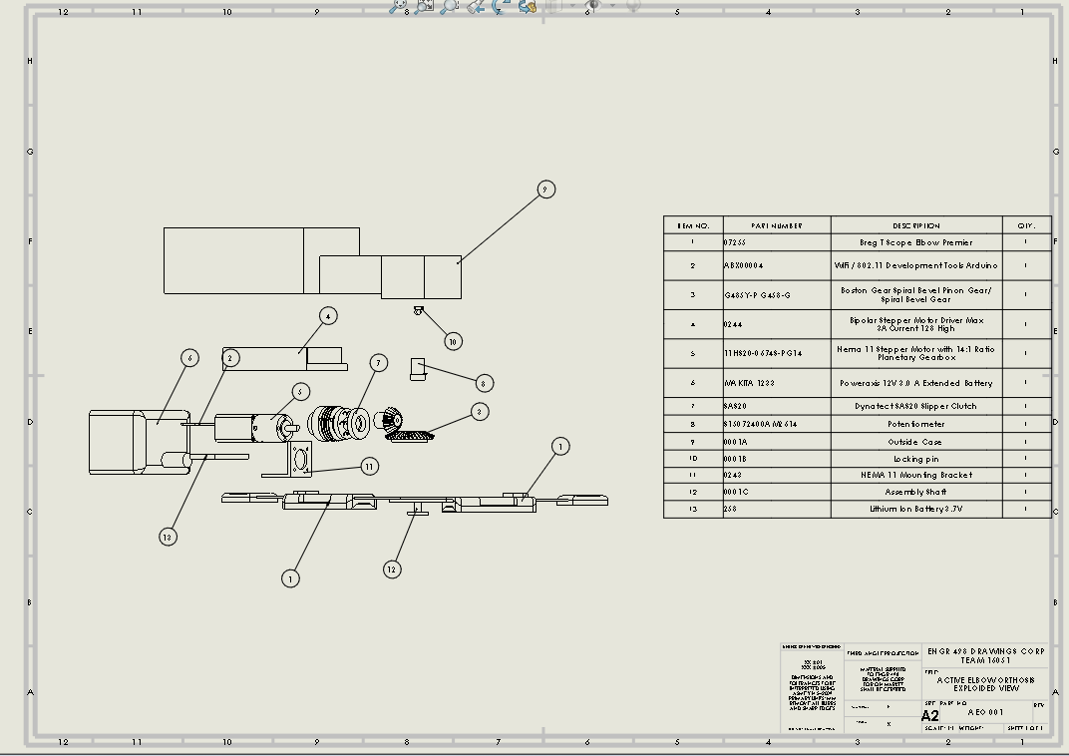

**10.2 Solidworks PDFs**

**1. Hinge Brace Assembly (Isometric view & Exploded view)**

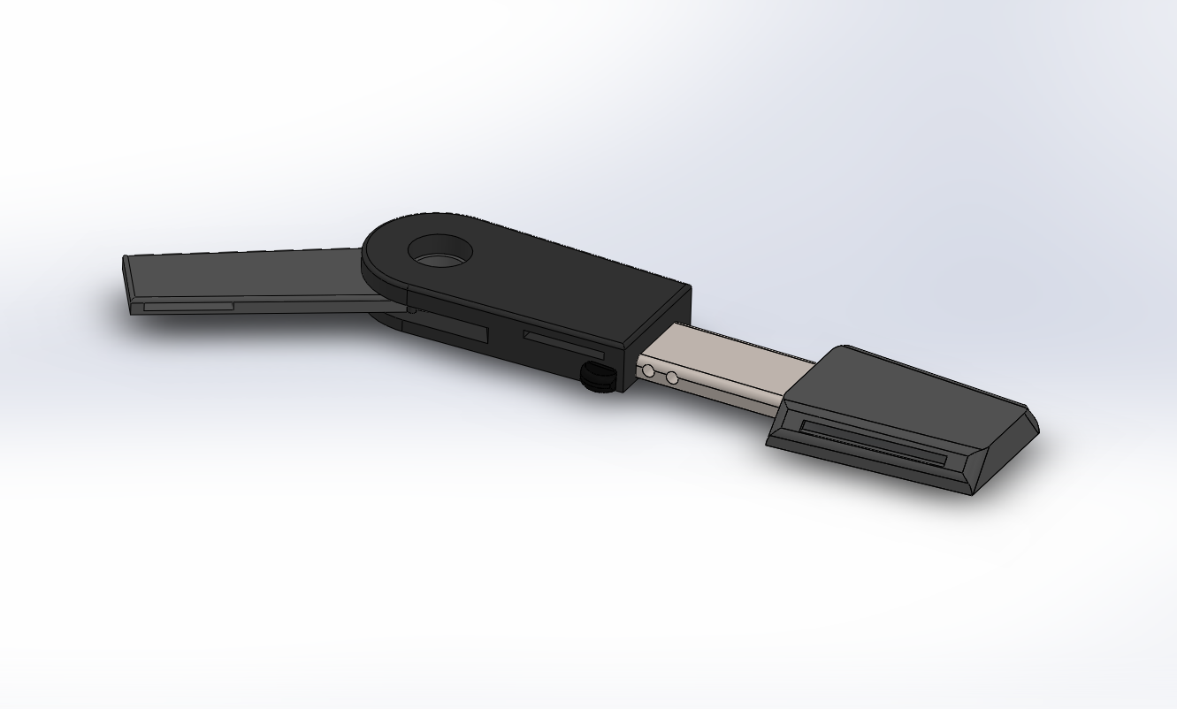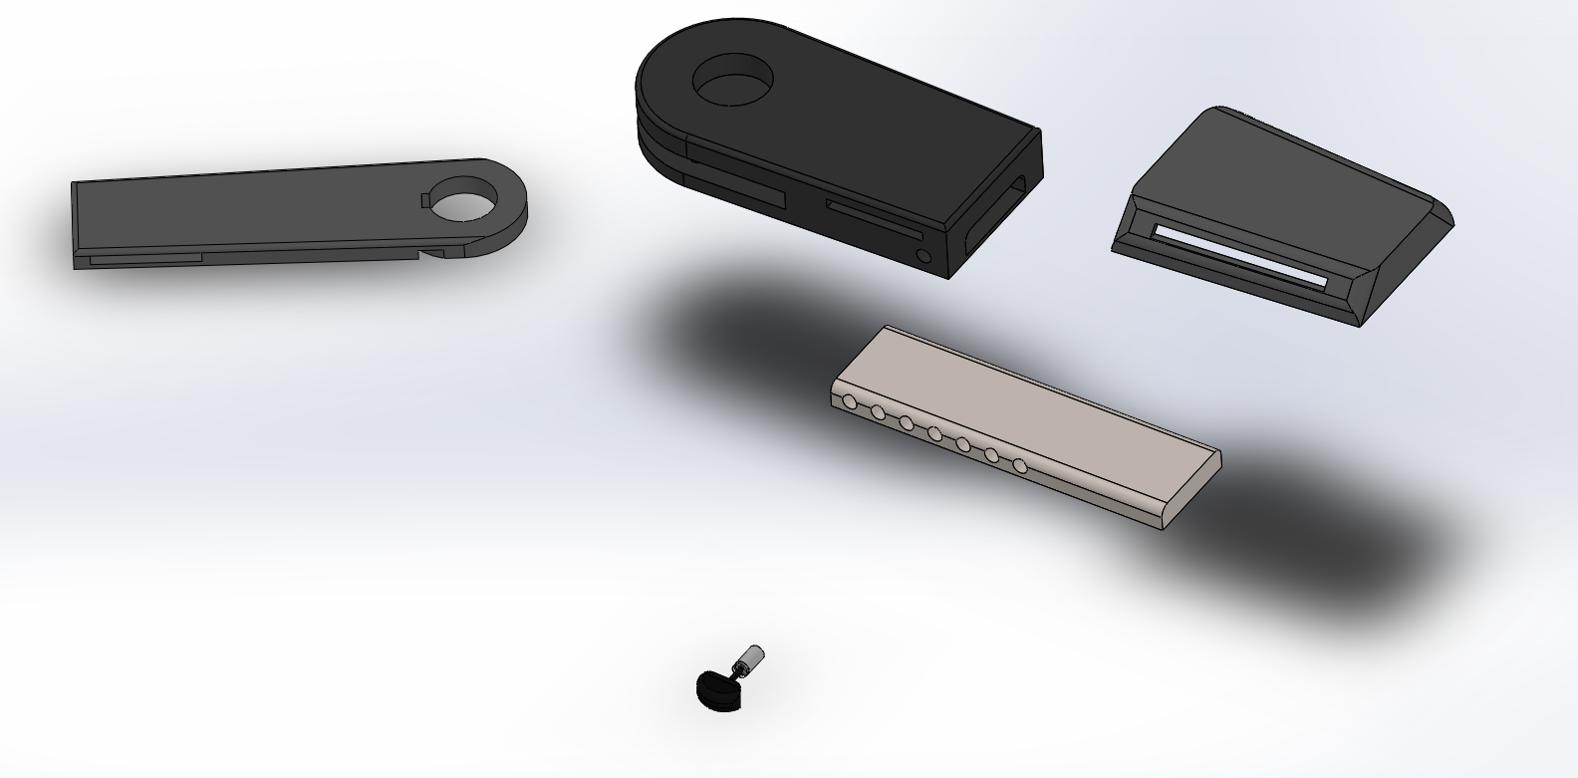

**2. Gearbox Assembly (Without top housing)**

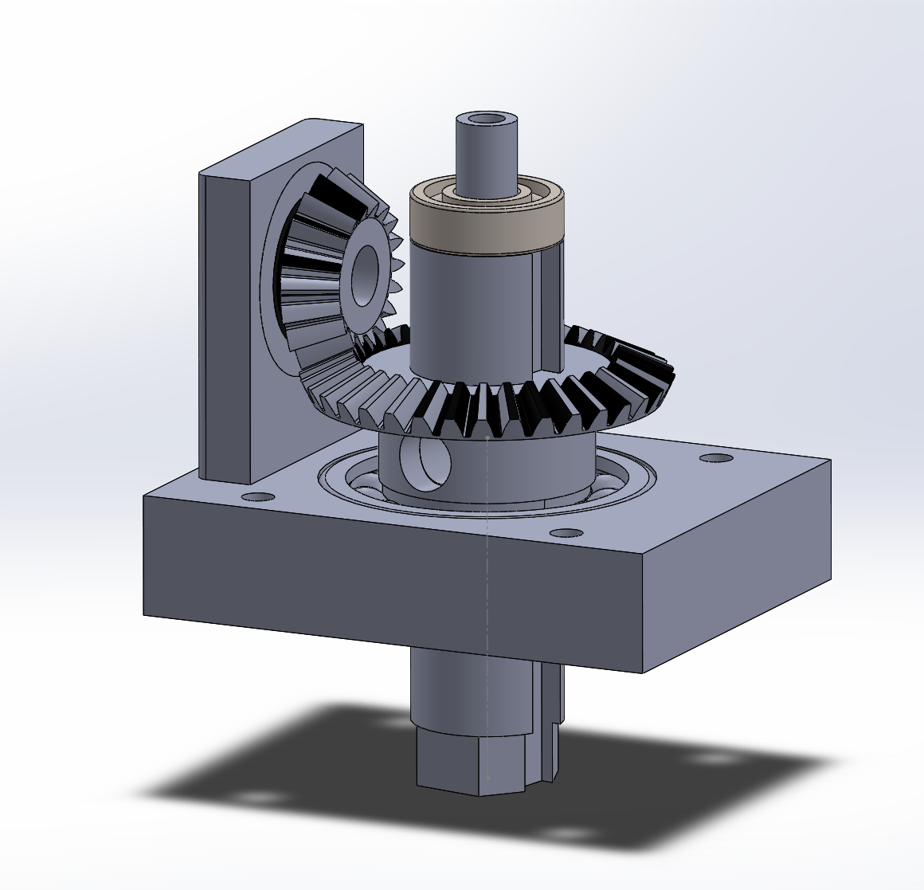

**3. AEO Assembly (Transparent case side view )**

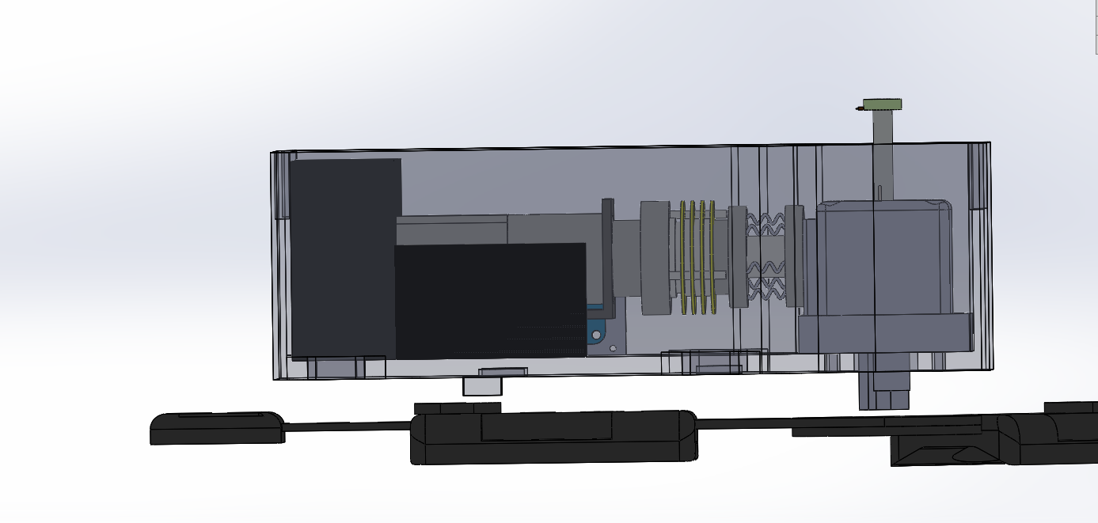

**4. AEO Assembly (Transparent case isometric view )**

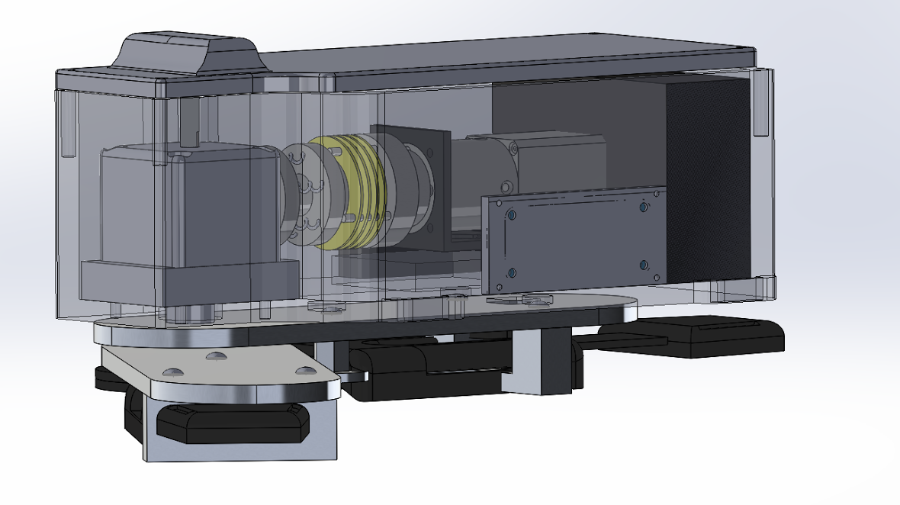

**5. AEO Assembly (Exploded view)**

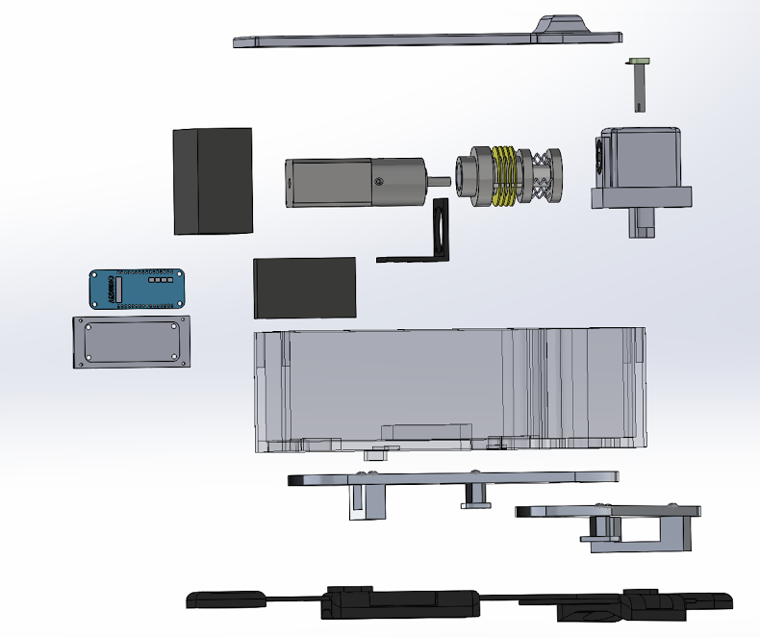

**10.2 Software PDFs**

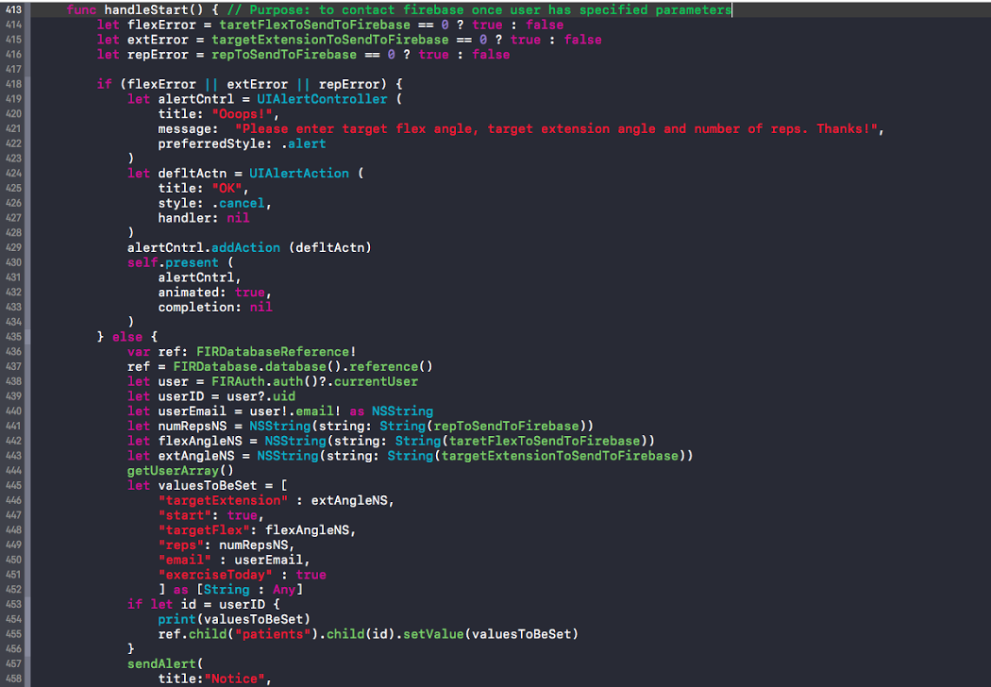

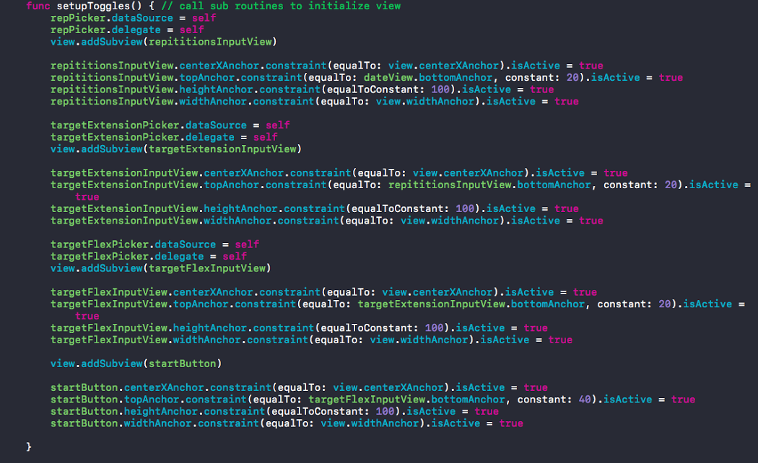

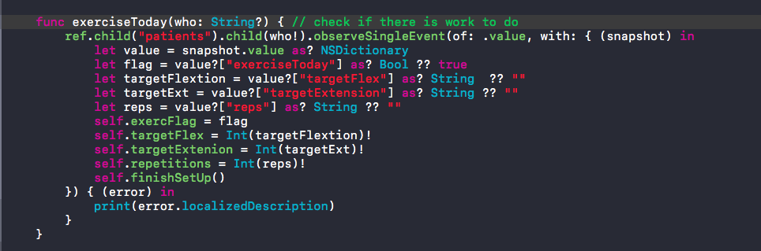

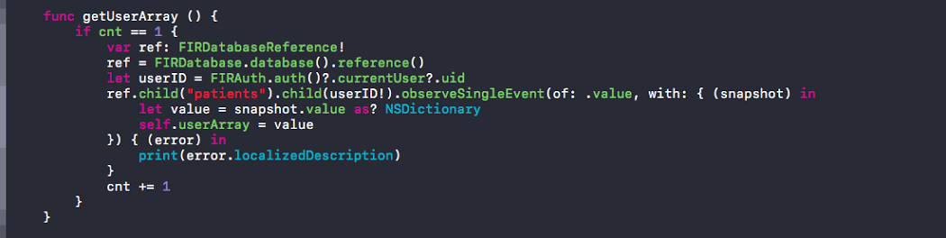

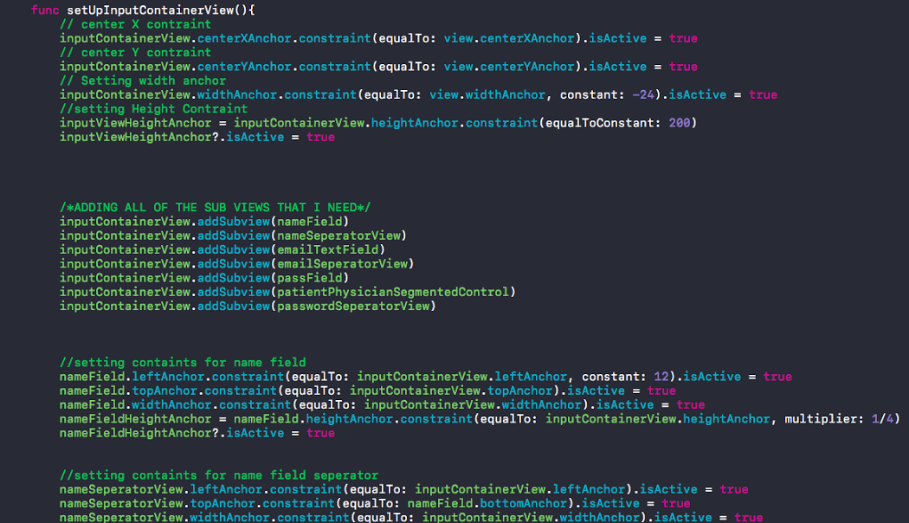

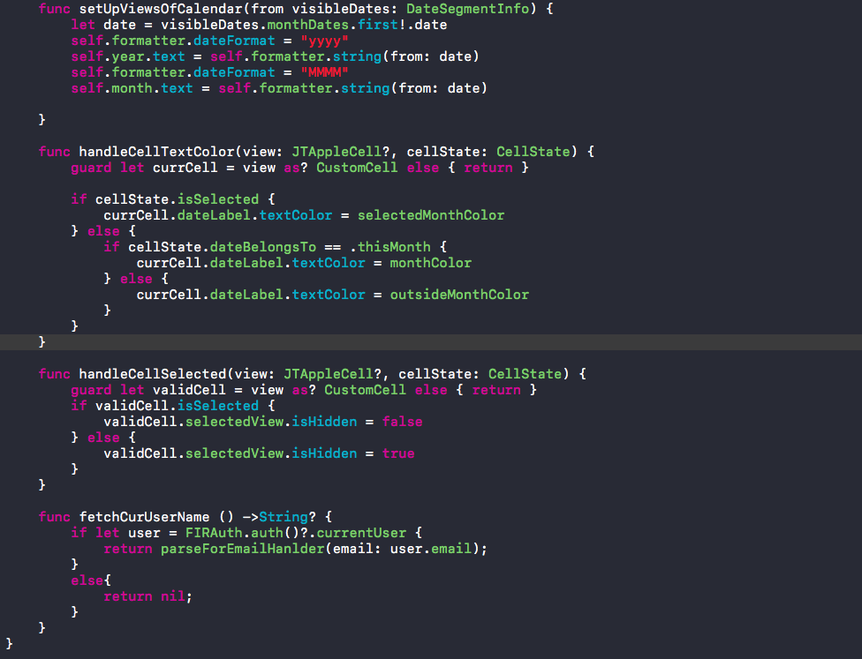

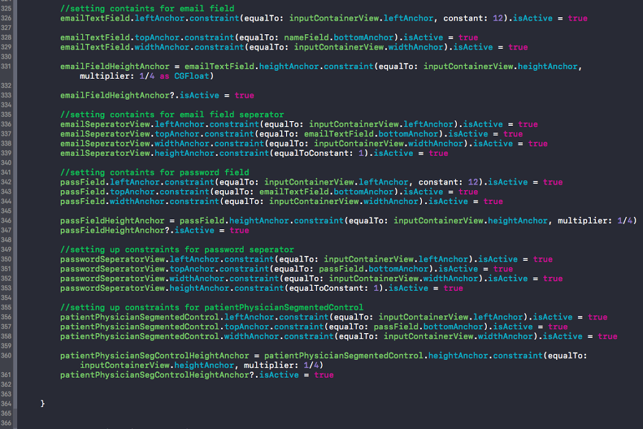

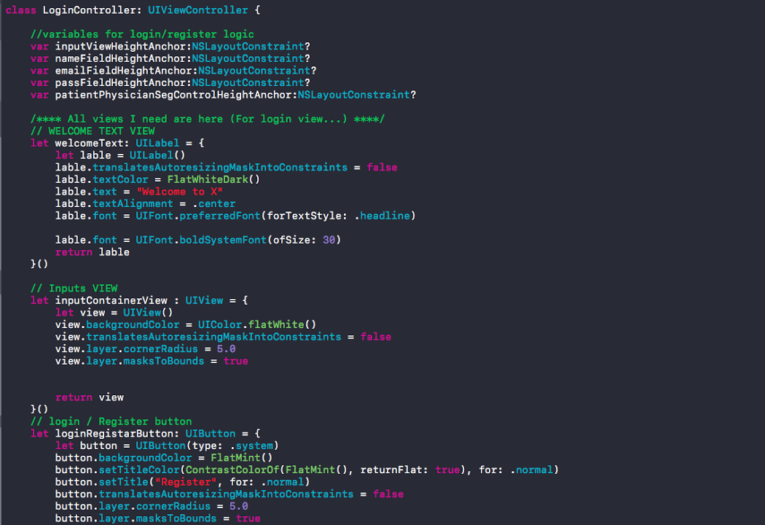

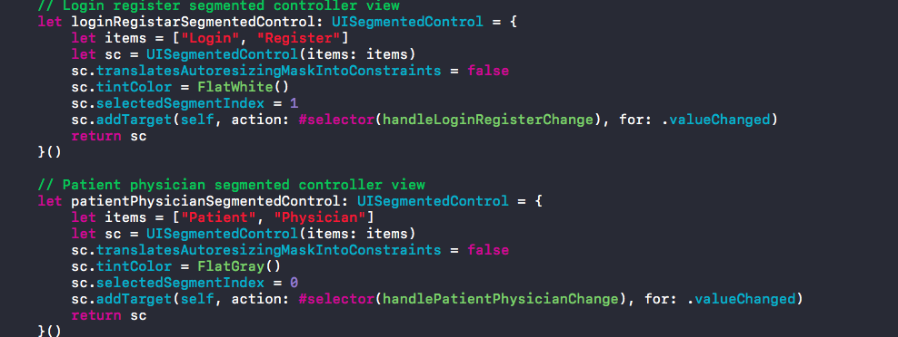

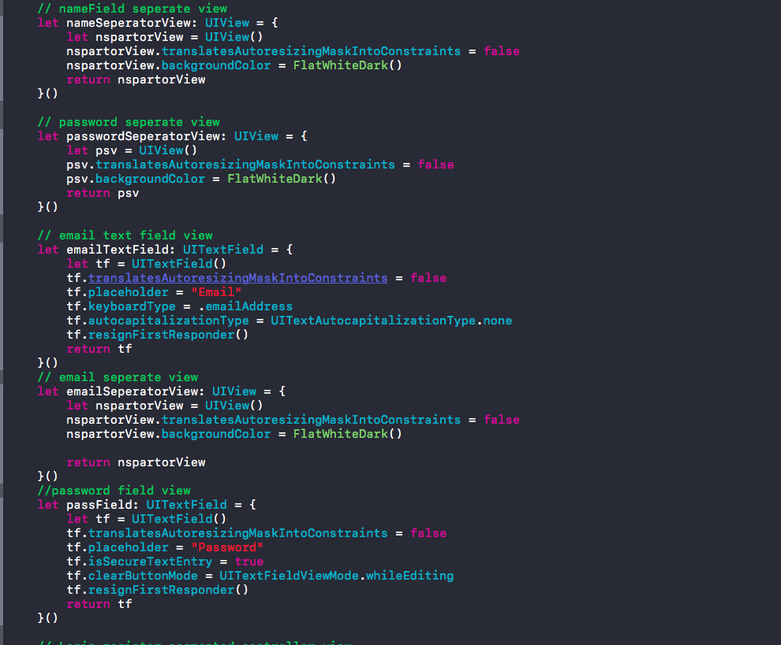

**10.3 Models and Analyses Documents**

**Torque Model:**

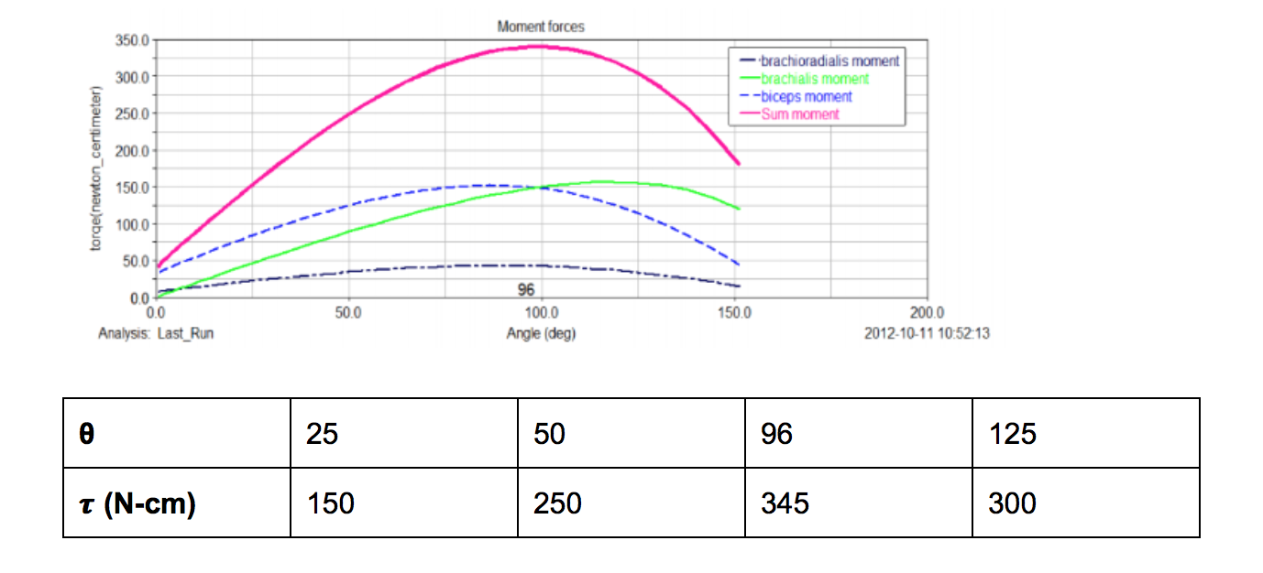

**Motor Power Model:**

Operating time = (time of one full flexion) * (20 cycles)   
 = (15 seconds) *20 = 300 seconds

Battery capacity = current * operating time = 0.67 Amps (max) * 300 seconds  
 = 55.8 mAmp-Hrs

**Sensor Model:**

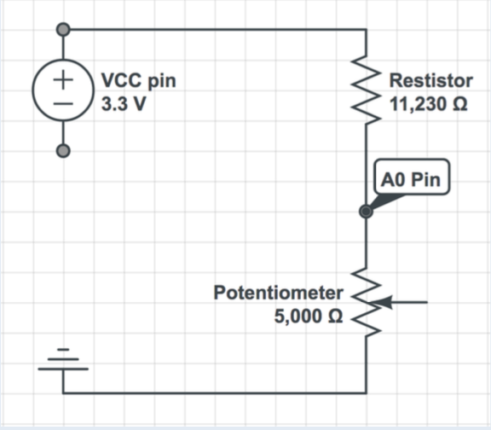

Initial Equation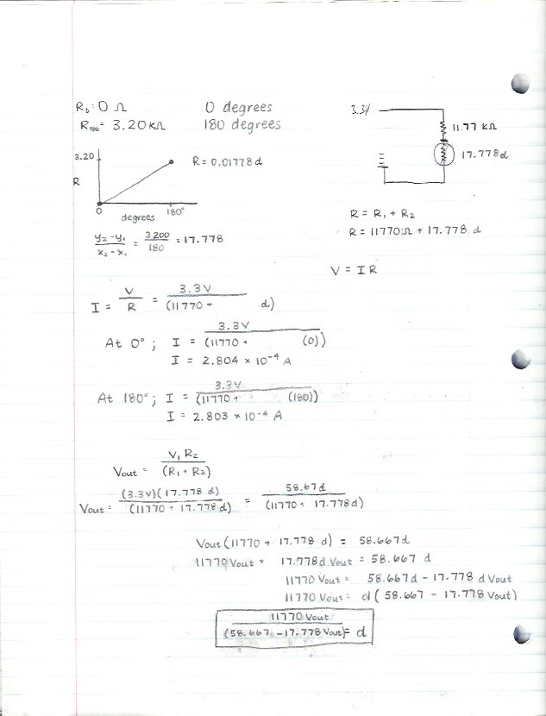

Final Equation and in terms of variables:

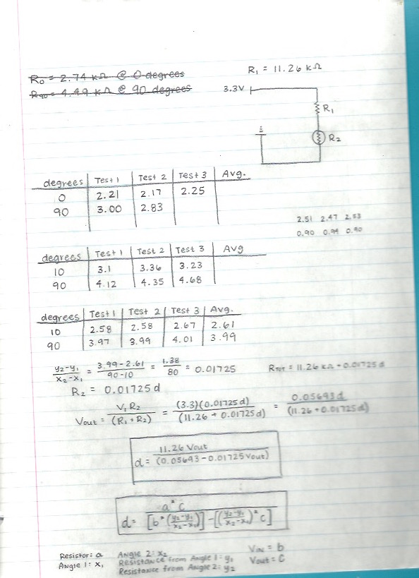

**Weight Analysis:**

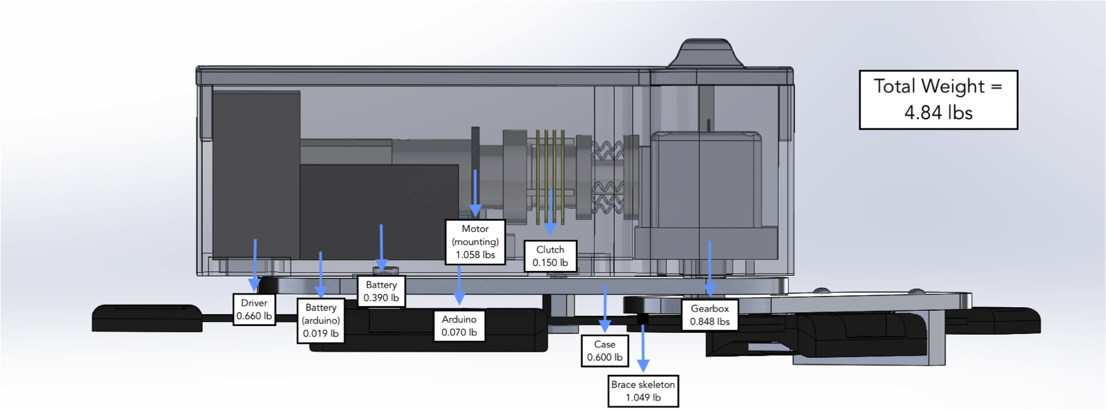

**Temperature Analysis:**

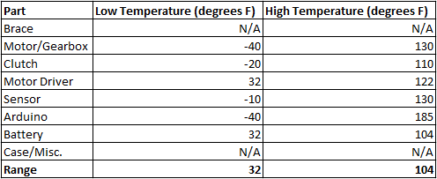

**Sensor Analysis:**

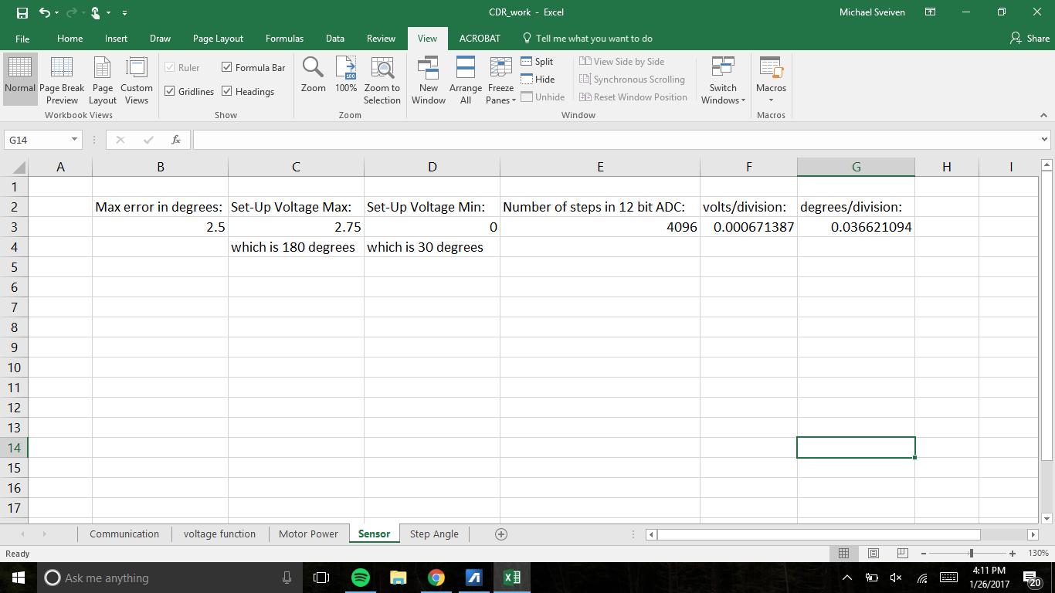

**Step Angle Analysis:**

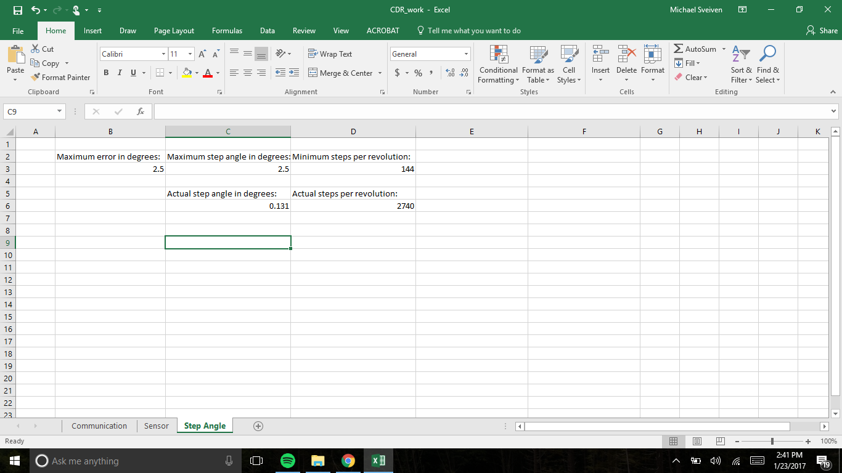

**Sampling Analysis:**

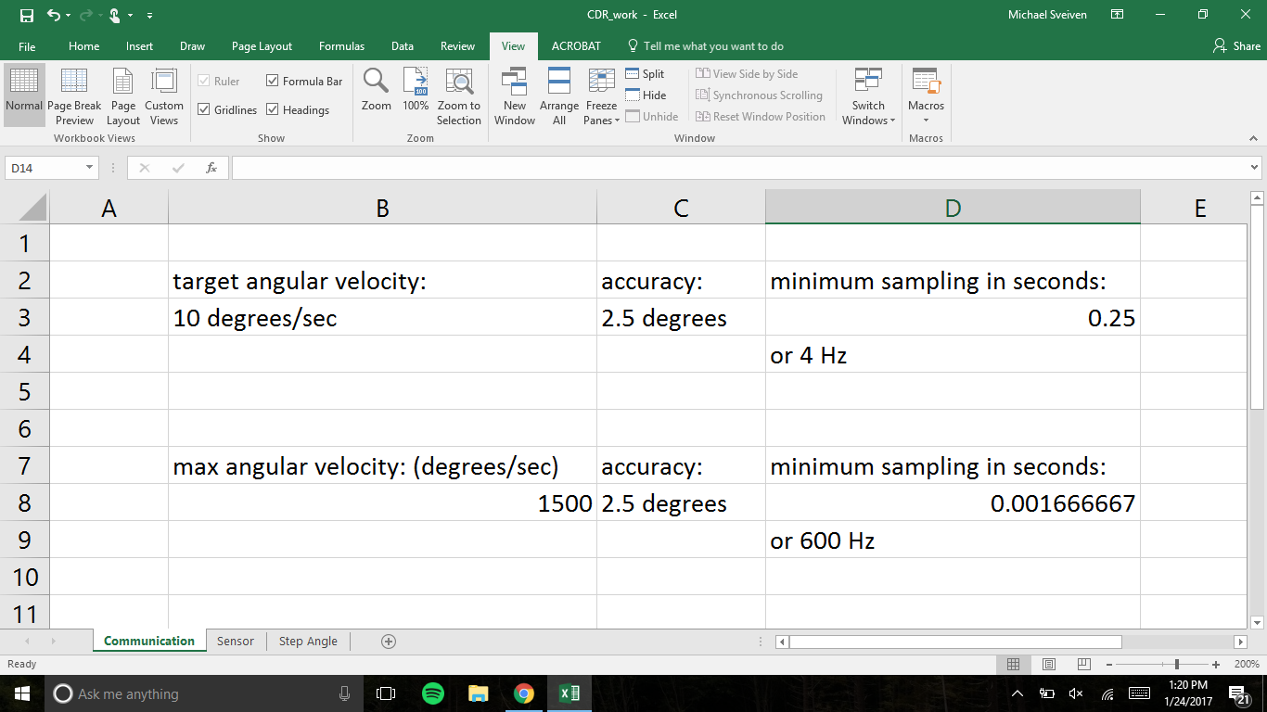

**10.4 Wireless Application Instruction Document**

**Active Elbow Orthosis (AEO) Application Instructional Document**

**Register:** To create a new user profile, begin by selecting the register tab on the welcome screen. Next, select a username, enter your username and create a password. Indicate whether you are a patient or a physician by selecting the appropriate tab and continue by clicking register. To view this profile during future uses of the application, select the login tab on the welcome screen.

**Login:** To login to a previously created profile, select the login tab on the welcome screen. Enter your username, password and indicate whether you are a patient or physician. Then, hit the login button, which will bring you to your profile homepage.

**Begin Exercise:** To begin an exercise, you will select start exercise on the welcome screen. This choice will bring you to the exercise screen. Once you are on the exercise screen, there will be button to start exercise. This will activate the device and a timer will begin timing the duration of the exercise. Another button will allow you to pause the exercise and, if paused, an option to stop the exercise will appear. The stop option will end the exercise.

**Messages:** To view any messages from the program or from the physician, you will select the messages option on the welcome screen. Here there will appear messages reminding you to perform your exercises or messages from the physician. If you are a physician and you wish to leave a message, you will select the new message option, enter the patient’s username and email and write your message in the box.

**Calendar:** If you wish to see your scheduled exercises, you will select the calendar option on the welcome screen. Once you are on the calendar screen, selecting the particular day will allow you to see the details of that day’s exercise. If you are a physician and you wish to add an exercise to a patient’s calendar, then you will select the plus sign and provide the details of the exercise.

**History:** If you wish to see your previous exercise history, you will select the history option on the welcome screen. The history screen will appear with a log of all previously scheduled exercises with an indication of whether the exercise was completed or not completed.

**Connect Sensor:** To connect the application to the AEO device, one will select the connect sensor option on the welcome screen. Once the application has been connected to the AEO device, there will be an indication on the screen that the device is connected.

**Settings:** If you wish to change the settings of the AEO device, you will select the settings button on the welcome screen.